**General questions**

1. (2020) Which types of decomposition do you know? Briefly explain and give their advantages and disadvantages.
   1. Functional decomposition - emphasizes the ordering of operations
      1. The system is decomposed into functional modules
      2. Each module is a processing step (function) in the application domain
      3. Modules can be decomposed into smaller modules
   2. Object-oriented decomposition - emphasizes the agents that cause the operations
      1. The system is decomposed into classes (“objects”)
      2. Each class is a major abstraction in the application domain
      3. Classes can be decomposed into smaller classes

For functional: easy to decompose but difficult to change

For ood: easy to change but difficult to decompose

1. (2020, 2017, 2014, 2013, 2010) A programming language is a notation for representing algorithms and data structures. List two advantages and two disadvantages of using programming language as sole (the only) notation throughout the software development process. (答案在2017)
   1. Advantages
      1. Developers need only learn one notation for all development activities
      2. Traceability among models and between models and code is made easier since they are written in the same notation
   2. Disadvantages
      1. A programming language is a low-level notation which is difficult to use for representing user requirements, for example.
      2. A programming language enables and encourages developers to represent implementation details too early.

1. (2019, 2018, 2015, 2013) What are basic ways to deal with complexity?

Abstraction (Ignore non-essential details),

Decomposition (Break problem into sub-problems),

Hierarchy (Simple relationship between chunks)

1. (2019, 2018, 2015, 2013) Which of the following are models?
   1. a UML class diagram
   2. a set of UML class diagrams describing the classes in a software system
   3. a 1:100 scale clay replica of a new sports car that will be used to test its aerodynamics in a wind tunnel
   4. a full-scale, working prototype of a new sports car

a) b) c) are models and d) is not. Because model is an abstraction of a system.

1. (2019, 2018, 2015, 2013) Consider the object model in Figure 1. Given your knowledge of the Gregorian calendar, modify the model such that a developer unfamiliar with the Gregorian calendar could deduce the number of days in each month, the number of weeks in each month, the number of months in a year and the number of days in a week? Identify additional classes and associations if necessary. (答案在2013)

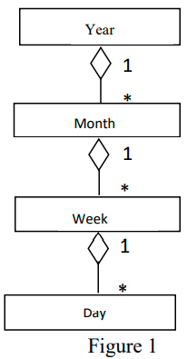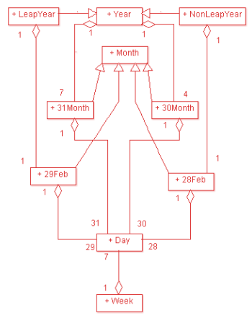

1. (2017, 2014) What is difference between the problem domain and the solution domain?

Problem domain: Represents all aspects of the user’s problem. This includes the physical environment in which the system will run, the users, and their work processes. The application domain is represented by the analysis model during requirements and analysis activities. The application domain is also called the problem domain. Contrast with solution domain.

Solution domain: The space of all possible systems. The solution domain is the focus of the system design, object design, and implementation activities. Contrast with application domain.

1. (2014) In the following description, explain when the term “account” is used as an application domain concept and when as a solution domain concept:

“Assume you are developing an online system for managing bank accounts for mobile customers. A major design issue is how to provide access to the accounts when the customer cannot establish an online connection. One proposal is that accounts are made available on the mobile computer, even if the server is not up. In this case, the accounts show the amounts from the last connected session.”

The first two are application domain and the last two are solution domain. Since the first two accounts are the real accounts in the bank. The rest two are described by proposal, which are possible systems.

1. (2012, 2009) Briefly explain difference between functional and object oriented decompositions. What are pros and cons for each of them?

见1

1. (2010) What are characteristics of software that make it different from other products? Briefly explain.
   1. computer programs
   2. associated documentation
   3. associated data that is needed to make the programs operatable
   4. intangible – it is difficult to understand development efforts
   5. untrained people can hack something together
   6. easily reproducible – cost is not in manufacturing but in development
   7. labor-intensive – hard to automate
   8. easy to modify
   9. a logical rather than physical product – it doesn’t wear out with use
2. (2008) A passenger aircraft is composed of several millions of individual parts and requires thousands of persons to assemble. A four-lane highway bridge is another example of complexity. The first version of Word for Windows, a word processor released by Microsoft in November 1989, required 55 person-years, resulted into 249,000 lines of source code, and was delivered 4 years late. Aircraft and highway bridges are usually delivered on time and below budget, whereas software is often not. Discuss what are, in your opinion, the differences between developing an aircraft, a bridge, and a word processor, which would cause this situation.

见9

1. (2006) Explain differences between a scientist, engineer and software engineer.
   1. (Computer) scientist
      1. concerns general theories and methods that underlie computer and software systems
      2. Has (almost) no time constraints
   2. Engineer
      1. works in application specific domain
      2. has time constraints
   3. Software engineer
      1. works in multiple application domains
      2. has time constraints
      3. changes can occur in requirements and technology
2. (2005) Explain dual role of software

**Life Cycle**

1. (2020, 2017, 2012) Specify which of the following decisions were made during requirements or system design (explain your answer):
   1. “The ticket distributor is composed of a user interface subsystem, a subsystem for computing tariff, and a network subsystem managing communication with the central computer.”
   2. “The ticket distributor will use PowerPC processor chips.”
   3. “The ticket distributor provides the traveler with an on-line help.

a）b) are system design while c) is requirements. For requirements, it focuses on what is the problem while for system design, it focuses on what is the solution.

1. (2020, 2017) Explain inductive program synthesis. What is/are its advantage(s) and what is/are its drawback(s)?

A program is built on the basis of input-output pairs or examples of computations.

1. (2020, 2012) Explain what is Model Driven Architecture?
   1. a software design approach for the development of software systems.
   2. provides a set of guidelines for the structuring of specifications, which are expressed as models.
   3. a kind of domain engineering, and supports model-driven engineering of software systems.
   4. launched by the Object Management Group (OMG) in 2001
   5. Models expressed in a well-defined notation are a cornerstone to understanding systems for enterprise-scale solutions.
   6. The building of systems can be organized around a set of models by imposing a series of transformations between models, organized into an architectural framework of layers and transformations.
   7. A formal underpinning for describing models in a set of metamodels facilitates meaningful integration and transformation among models, and is the basis for automation through tools.
   8. Acceptance and broad adoption of this model-based approach requires industry standards to provide openness to consumers, and foster competition among vendors.
2. (2019, 2018, 2015, 2012) Give an explanation of V-Model? What are/is its main difference(s) compare to Waterfall model? What is its main weakness?

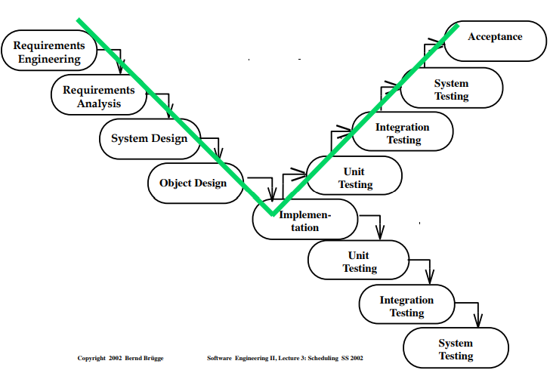

A variation of the waterfall model that makes explicit the dependencies between development processes and verification processes. In practice, software development is not sequential and the development stages overlap. Different stakeholders need different abstractions. System development is a nonlinear activity.

1. (2019, 2015, 2013, 2010) Explain what is common and what is different between transformational and deductive synthesis. Explain what is common and what is different between transformational synthesis and Model Driven Architecture (MDA)
   1. deductive methods, which uses automatic deduction of a proof of solvability of a problem and derives a program from the proof. transformational methods, where a program is derived stepwise from a specification by means of transformations.
      1. Both of them are based on deduction, however, they use different deduction methods.
      2. Synthesis is usually based on inference, whereas transformation is usually based on replacement
      3. Inference means the axioms and rules supplied to the program derivation system are expressed as implications, and the logical operations of the system derive either necessary conclusions or premises of sufficient antecedents of goals
      4. Replacement means that the axioms supplied to the system are expressed as equations or rewrite rules, and the logical operations replace expressions by other equivalent expressions.
2. (2017) What is difference between activities and tasks? What are main Software Engineering activities?
   1. Task – atomic unit of work to be managed
      1. consumes Resources
      2. produces Work Products
      3. depends on other tasks
      4. F/E develop “Out of Change” test case
   2. Activity – set of tasks performed for achieving the project’s goals
      1. F/E buy a ticket

Activities are analysis, design, implementation and testing.

1. (2014) For each of the following documents, indicate in which phase(s) of the software life-cycle it is produced: final user manual, architectural design, module specification, source code, test plan, preliminary user manual, detailed design, project plan, cost estimate, test report, documentation.

Project Management: project plan, cost estimate

Pre-development: architectural design

Development: module specification, source code, detailed design

Post-development: final user manual

Integral: test plan, preliminary user manual, test report, documentation

1. (2014) Draw a UML class diagram representing Unified Software Development Process (UP)?

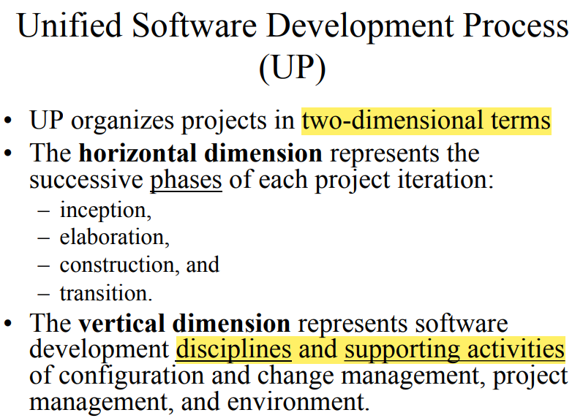

1. (2014, 2012) We considered 3 formal software development models: inductive, deductive and transformational. Briefly (without technical details) explain main features of each of these models
   1. inductive methods, where a program is built on the basis of input-output pairs or examples of computations
   2. deductive methods, which uses automatic deduction of a proof of solvability of a problem and derives a program from the proof
   3. transformational methods, where a program is derived stepwise from a specification by means of transformations
2. (2013, 2010) Unified Software Development Process (UP) considers phases, iterations and workflows in software life cycles. Briefly explain each of them and how they are related. Use figures where appropriate.

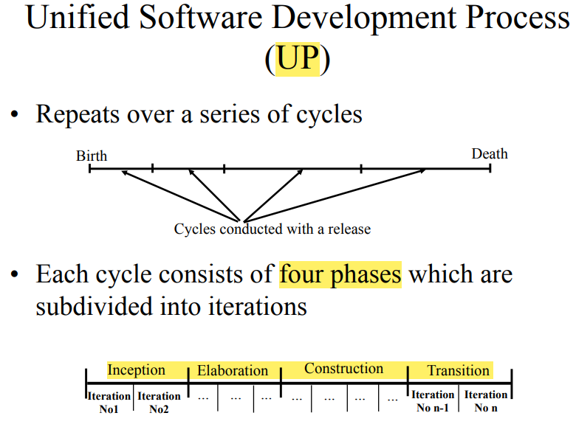

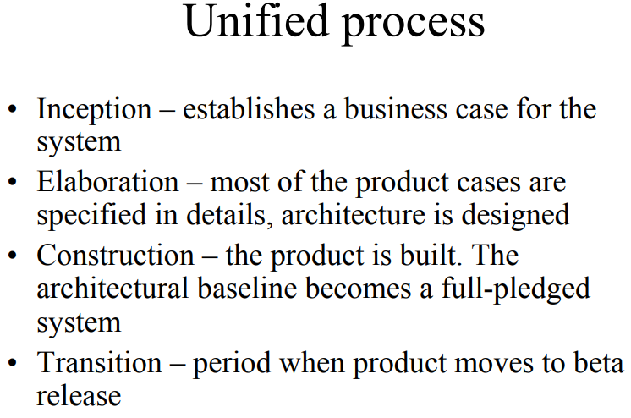

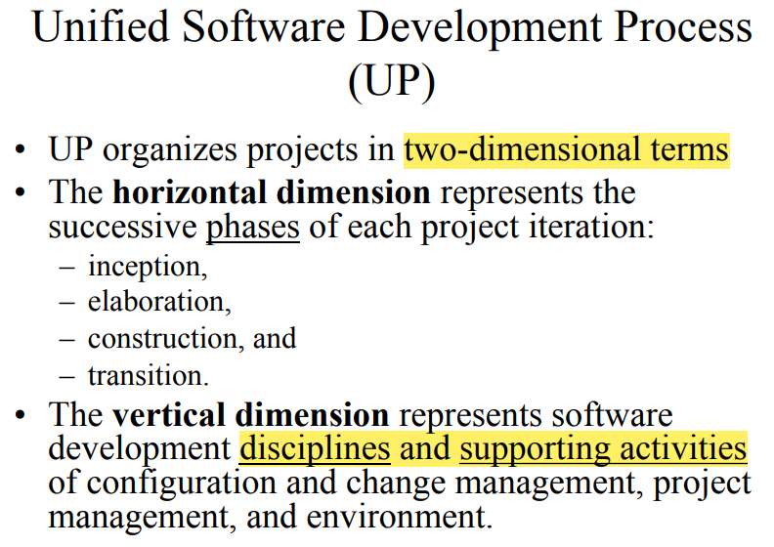

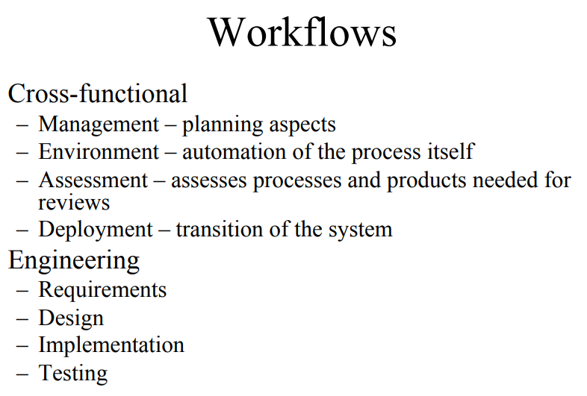

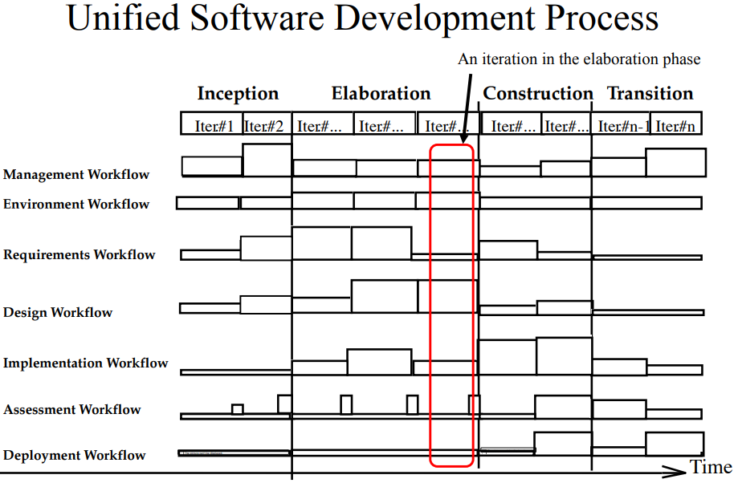

1. (2008) Give an explanation of Spiral Model? What are main problems of waterfall model that Spiral model overcomes?
   1. For each cycle go through these activities
      1. – Quadrant IV: Define objectives, alternatives, constraints
      2. – Quadrant I: Evaluate alternative, identify and resolve risks
      3. – Quadrant II: Develop, verify prototype
      4. – Quadrant III: Plan next cycle

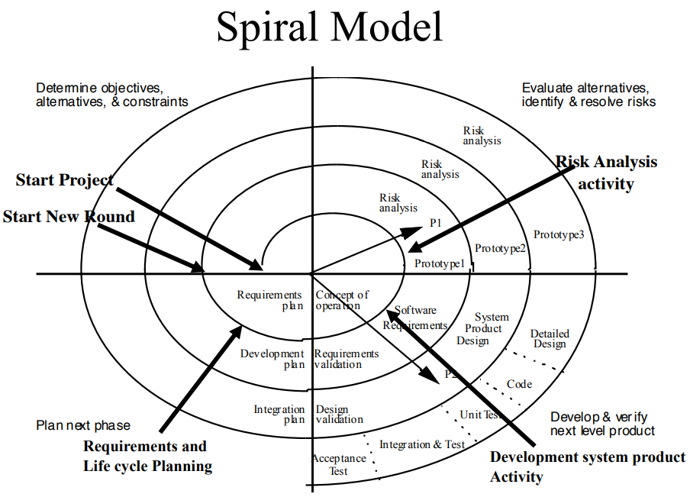

* 1. In practice, software development is not sequential and system development is a nonlinear activity. Software development is iterative

1. (2008) Software life-cycles may be different for different projects. Why?

Different stakeholders need different abstractions. For developing group with different number of people, some software life-cycle may not suitable for them. Different software also suit for certain life-cycle.

1. (2005) What is difference between activity-centered and entity-centered life cycles? Which of them is dominating now?

Activity-centered focuses on different activities during life cycles. Entity-centered focuses on the frequent change during the life cycles. Activity-centered is dominating now.

1. (2005) Draw Boehm’s spiral model as a UML activity diagram. Does the activity diagram improve readability compare to the original figure?

见11

**UML&OOP**

1. (2020) Give an example of object description in UML class diagram notation.

Underline, attribute

1. (2020, 2012, 2010) Explain difference between <<extend>> and <<include>> in use case diagrams.

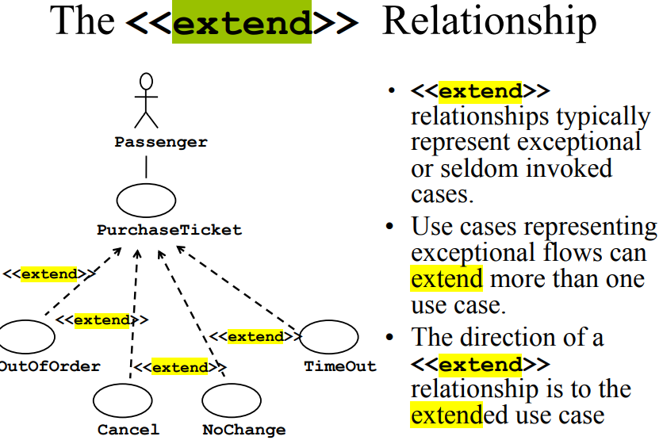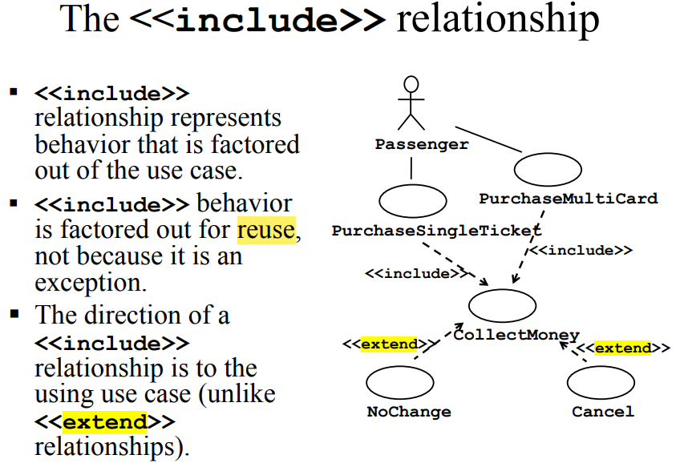

1. (2020, 2014, 2012, 2010) Using only one class draw a class diagram which states that a course has successor(s) and prerequisite(s) and if two courses cover nearly the same material, taking one of them may preclude a student from taking the other and vice versa (courses are mutually exclusive).

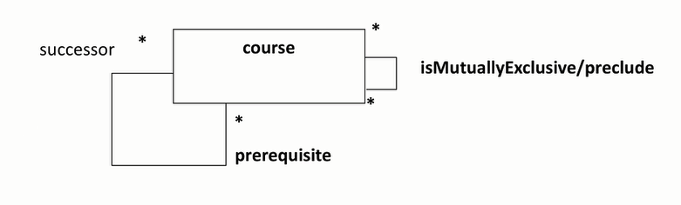

1. (2019, 2015, 2013, 2010) What is/are difference(s) between Sequence diagrams and Communication diagrams? When each of them is more appropriate to use?
   1. Sequence diagrams – UML notation representing the behavior of the system as a series of interactions among a group of objects. Each object is depicted as a column in the diagram. Each interaction is depicted as an arrow between two columns. Sequence diagrams are used during analysis to identify missing objects, attributes, or relationships. Sequence diagrams are used during object design to refine the specification of classes. See also communication diagram. Describe the dynamic behavior between actors and the system and between objects of the system
   2. Communication diagrams – UML notation representing the behavior of the system as a series of interactions among a group of objects. Each object is depicted as a rectangle in an instance diagram. Interactions are depicted as lines between objects, annotated with the name of the message sent. The order of interactions is represented with numbers next to the message names. See also sequence diagram. Alternative presentation of sequence diagrams

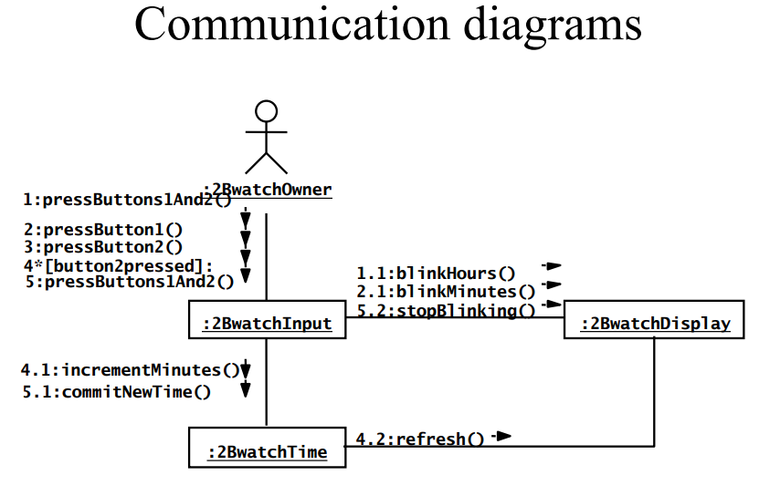

1. (2018, 2015) Which of the following kinds of use-case(s) is (are) always independently meaningful and operational? Explain you answer
   1. An extension(extending) use-case
   2. An extended use-case
   3. An including(base) use-case
   4. An included use-case
2. (2018, 2015) Finish the correct statements about Use Cases relationships: Use …when you are repeating yourself in two or more separate use cases and you want to avoid repetition. Use ....... when you have one use case that is similar to another use case but does a bit more. Use ……. when you are describing a variation on normal behavior and you wish to use a controlled form, declaring your extension points in your base use case.
   1. Include
   2. Generalization
   3. Extend
   4. Delegation

a, d, c

1. (2020, 2017) Organize the following set of classes into hierarchies: Circle, Point, Rectangle, Matrix, Ellipse, Line and Plane. You can add any additional classes into your hierarchy.

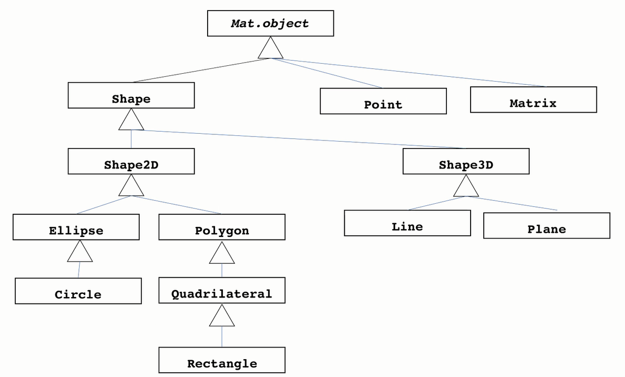

1. (2017, 2006) Can the system under consideration be represented as an actor? Justify your answer.

No. Actors represent roles, that is, a type of user of the system. An actor models an external entity which communicates with the system:

– User

– External system ------------------not external

– Physical environment

An actor has a unique name and an optional description.

1. (2017) Show how condition and iteration can be presented in a sequence diagram.

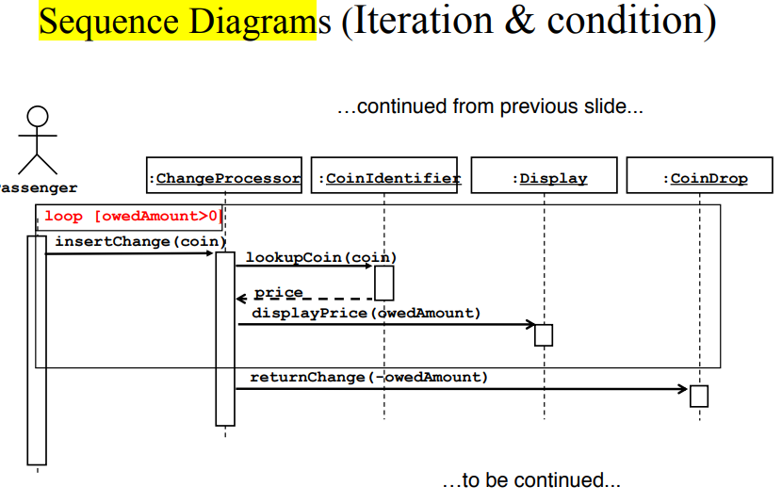

1. (2014) Classify the following relationships as either and inheritance relationship, an aggregation relationship or a general association:
   1. Car - Lincoln town car inheritance
   2. Person – student inheritance
   3. Library – Library employee aggregation
   4. Book – Copy general association
   5. Car – Driver general association
   6. Library employee – Book loan general association
   7. Class – Students aggregation
2. (2013) Draw a UML activity diagram describing the dependency between activities for a life cycle in which requirements, design, implementation, test, and maintenance occur both concurrently and iteratively.

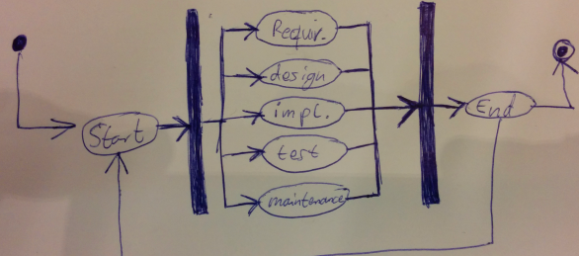

1. (2012) Explain difference between Concept and Phenomena. Give an example of Concept and Phenomena in software.
   1. Phenomenon – An object in the world of a domain as you perceive it – Example: The lecture you are attending
   2. Concept – Describes the properties of phenomena that are common. – Example: Lectures in software engineering course
   3. Concept is a 3-tuple: – Name (To distinguish it from other concepts) – Purpose (Properties that determine if a phenomenon is a member of a concept) – Members (The set of phenomena which are part of the concept)
2. (2008) Both Activity and Statechart diagrams are described as graphs. What is difference between Activity and Statechart graphs?
   1. State diagrams – Describe the dynamic behavior of an individual object (essentially a finite state automaton)
   2. Activity Diagrams – Model the dynamic behavior of a system, in particular the workflow (essentially a flowchart)

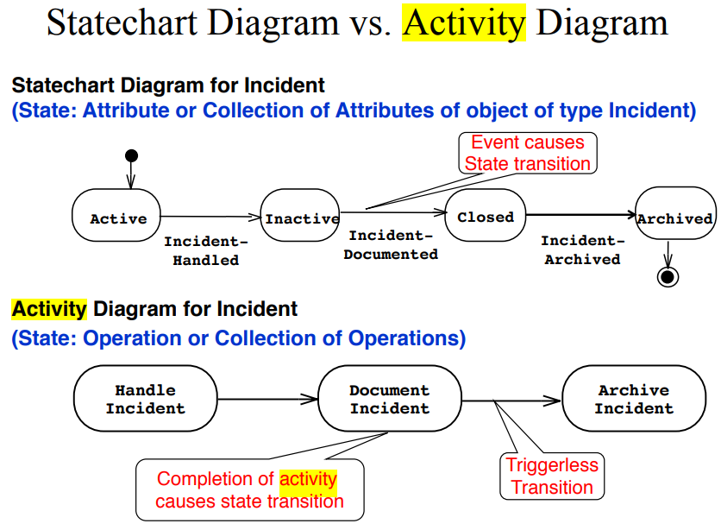

1. (2007) For textual description of use cases we use a template composed of six fields.
   1. Explain what are these fields? Name, Participating actor(s), Entry Conditions, Exit Condition, Quality Conditions, Event Flow
   2. How do we represent include and extend relationships in the textual description of use cases? Extend are expressed in entry condition, include are expressed in event flow.
2. (2005) What is difference between an actor, a class and an instance? Give examples.
   1. Actors represent roles, that is, a type of user of the system. An actor models an external entity which communicates with the system:

– User

– External system

– Physical environment

An actor has a unique name and an optional description.

* 1. Class

– A template from which instances of the class (objects) can be created

– Carrier of properties common to the objects of the class

* 1. An instance represents a phenomenon, Member of a specific type

1. (2005) Draw a class diagram representing the relationship between parents and children. Take into account that a person can have both a parent and a child. Requirement: your class diagram must contain only one class

见7

**Requirement elicitation**

1. (2020, 2017, 2015, 2013) Specify which of these requirements are verifiable and which are not. Explain your answer.
   1. “The system must be usable.” NO: Not verifiable, because not meisurable. What does "usable" mean?
   2. “The system must provide visual feedback to the user within 1 second of issuing a command.” YES: Can be meisured. Whether the time of feedback is higher or lower than 1 second
   3. “The availability of the system must be above 95%.” YES: We cannot predict the furute. We dont know if in 2 years the system might not work e.g. for 3 consecutive months.？？？？？？？？enough resources to run
   4. “The user interface of the new system should be similar enough to the old system such that users familiar with the old system can be easily trained to use the new system.” NO: We cannot meisure "ease" or "similariry". We have to rely on user's feedback but cannot verify.
2. (2018, 2015, 2013, 2007) What are main types of requirements? Briefly explain each of them
   1. Functional requirements:
      1. Describe the interactions between the system and its environment independent from implementation
      2. Examples: • An ARENA operator should be able to define a new game.
   2. Nonfunctional requirements:
      1. User visible aspects of the system not directly related to functional behavior.
      2. Examples: • The response time must be less than 1 second • The ARENA server must be available 24 hours a day
      3. Usability, Reliability, Performance, Supportability,
      4. (implementation related, user visible aspects (see homework))
3. (2018, 2014, 2008) Maintaining traceability during requirements and subsequent activities is expensive, because of the addition information that must be captured and maintained. What are the benefits of traceability that outweigh this overhead?

The property of a model describing whether a model element can be traced to the original requirement or rationale that motivated its existence. Traceability is critical for developing tests and for evaluating changes. When developing tests, traceability enables a tester to assess the coverage of a test case, that is, to identify which requirements are tested and which are not. When evaluating changes, traceability enables the analyst and the developers to identify all components and system functions that the change would impact. Traceability enables developers to show that the system is complete, testers to show that the system complies with its requirements, designers to record the rationale behind the system, and maintainers to assess the impact of change

1. (2017, 2014, 2012) We identified the following types of scenario: As-Is, Visionary, Evaluation and Training scenario. Briefly explain each of them and give examples.
   1. As-is scenario: – Used to describe a current situation. Usually in reengineering. The user describes the system.
   2. Visionary scenario: – Used to describe a future system. Usually used in Greenfield engineering and Reengineering projects. – Can often not be done by the user or developer alone
   3. Evaluation scenario: – User tasks against which the system is to be evaluated
   4. Training scenario: – Step by step instructions that guide a novice user through a system
   5. Scenarios can have many different uses during the software lifecycle

– Requirements Elicitation: As-is scenario, visionary scenario

– Client Acceptance Test: Evaluation scenario

– System Deployment: Training scenario.

1. (2017) Explain why multiple-choice questionnaires, as a primary means of extracting information from the user, is not effective for eliciting requirements.

It is a passive technique, no possibility to clarify questions and answers. who are the people which did not respond? how would they respond? It provides answers to the questions, so the analyst must be familiar enough with the application domain to offer a good set of answers for each question. The user is constrained within this answers. However, the user may have some other answers.

1. (2012) What is difference between traditional and modern methods for requirements elicitation? When each of them is more appropriate?
   1. Traditional methods ------ more about get information from others
      1. Interviewing customers and domain experts
      2. Questionnaires
      3. Observation
      4. Study of documents and software systems
   2. Modern methods -------- come up with information by developers
      1. Prototyping
      2. Brainstorming
      3. Joint Application Development (JAD)
      4. Rapid Application Development (RAD)
2. (2010) Which requirements validation criteria do you know? Briefly explain them. Give an example of a requirement that can’t be validated.
   1. Correctness: • The requirements represent the client’s view.
   2. Completeness: • All possible scenarios, in which the system can be used, are described, including exceptional behavior by the user or the system
   3. Consistency: • There are no functional or nonfunctional requirements that contradict each other
   4. Unambiguity: • A requirements cannot be interpreted in mutually exclusive ways
   5. Realism • if the system can be implemented within constraints
   6. Verifiability • if repeatable tests can be designed to demonstrate its work
   7. Traceability • if each requirement can be traced throughout the software development

The product shall have a good user interface

1. (2009) What are at least three differences between the analysis model and the design model of a software product?
2. (2008) The need for developing a complete specification may encourage an analyst to write detailed and lengthy documents. Which requirement validation criteria(s) may encourage an analyst to keep the specification short?
   1. Verifiability • if repeatable tests can be designed to demonstrate its work
   2. Traceability • if each requirement can be traced throughout the software development
3. (2008) Name categories of nonfunctional requirements suggested by FURPS+ model. Which of them are quality requirements and which of them are constraints or pseudo requirements?
   1. Categories reflecting: usability, efficiency, reliability, maintainability
      1. Usability – ease of use – documentation and help, training, user interface, error handling
      2. Reliability – mean time between failures, graceful recovery, dependable (we can depend on it) = reliability +robustness+safety
      3. Performance – response time, transaction throughput, resource consumption, concurrency level, uninterrupted availability, accuracy of results – efficiency – in terms of time and cost
      4. Supportability = adaptability + maintainability + portability
   2. Categories constraining the environment and technology of the system.
      1. Implementation, interface, operations, packaging, policy and legal issues
   3. Categories constraining the project plan and development methods
      1. Development process (methodology) to be used
      2. Cost and delivery date – Often put in contract or project plan instead
4. (2007) What are main types of scenarios? Briefly explain them.
   1. As-is scenario: – Used to describe a current situation. Usually in reengineering. The user describes the system.
   2. Visionary scenario: – Used to describe a future system. Usually used in Greenfield engineering and Reengineering projects. – Can often not be done by the user or developer alone
   3. Evaluation scenario: – User tasks against which the system is to be evaluated
   4. Training scenario: – Step by step instructions that guide a novice user through a system
   5. Scenarios can have many different uses during the software lifecycle

**Requirement specification/Analysis**

1. (2020, 2017) Both sequence diagrams and statecharts diagrams can be used in analysis. When each of them is more appropriate?
   1. Model interaction between objects => sequence diagram
   2. Model dynamic behavior of a single object => statechart diagram
2. (2020) What is difference between fork and stair structure of UML Sequence diagram? For which types of system each of them is more suitable?
   1. Fork - Centralized control structure better support of change (because of encapsulation in one object)
      1. The operations can change order
      2. New operations can be inserted as a result of new requirements
   2. Stair - Decentralized control structure
      1. The operations have a strong connection
      2. The operations will always be performed in the same order
3. (2020, 2017) Consider a traffic light system at a four-way crossroads (e.g., two roads intersecting at right angles). Assume the simplest algorithm for cycling through the lights (e.g., all traffic on one road is allowed to go through the crossroad while the other traffic is stopped). Identify the states of this system and draw a statechart describing them. Remember that each individual traffic light has three states (i.e. green, yellow, and red).

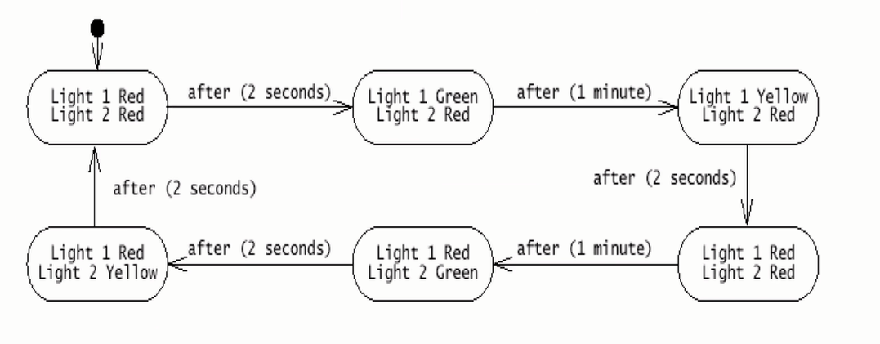

1. (2019, 2018, 2015, 2013) Why do we apply principle of Falsification in software engineering?

Principle of Falsification – demonstrating that relevant details of model are presented incorrectly or not presented at all. Because it is impossible to show that a model is correct or correctly represents reality. We can only build models from reality, which are “true” until we have found a counter example. By falsifying we can remove certain obvious mistakes in order to make the model "more correct" or "less wrong".

1. (2018, 2015, 2013) There are different approaches to class identification. In practice, the process of class discovery is likely to be guided by different approaches at different times. Give a scenario of a mixed approach to class discovery involving at least 4 other approaches.
   1. Application domain approach: • Ask application domain expert to identify relevant abstractions
   2. Syntactic approach: • Use noun-verb analysis (Abbots technique) to identify components of the object model (from descriptions or from use cases - extract participating objects from flow of events)
   3. Common class pattern approach • Use generic classification theory of objects
   4. Design patterns approach • Use reusable design patterns
   5. Component-based approach: • Identify existing solution classes
   6. Object types approach

The initial set of classes may be discovered from the generic knowledge and experience of analysts. The common class patterns approach can provide additional guidance. Other classes may be added from the analysis of high level descriptions of the problem domain using the noun phrase approach. If use-case diagrams are available, then the use-case driven approach can be used to add new and verify existing classes. Finally, the CRC approach will allow brainstorming the list of classes discovered so far.

1. (2018, 2015, 2013) Give an example of a problem where Aspect-Oriented Programming is useful to apply. Your example must be different from the examples presented in the Lecture Notes of the course.

Some problems are not attached to any particular domain but they are spread across them.

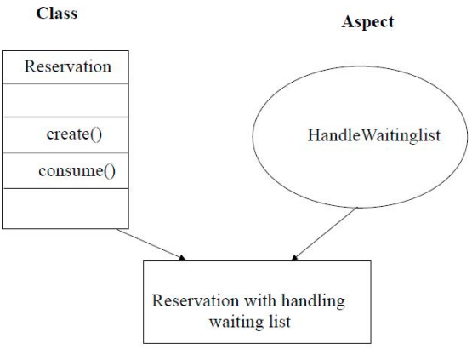

1. (2017) Let us consider a scenario consisting of selecting a file on a memory stick, dragging it to Folder representing a file system on your computer and releasing the mouse. Identify and define at least one control object associated with this scenario.
2. (2014) There are trade-offs between different design goals. Give at least 3 examples of such trade-offs and briefly explain them.

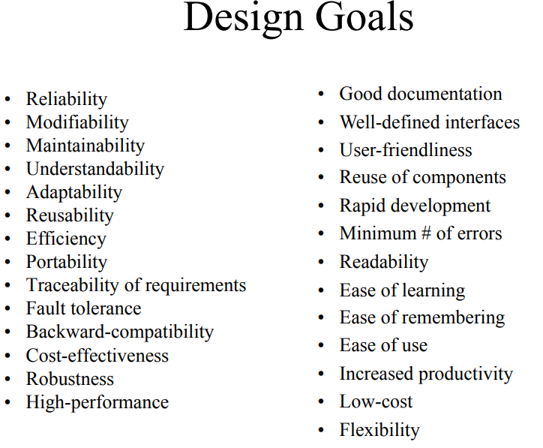

1. (2014, 2012, 2010) Consider a file system with a graphical user interface, such as Microsoft’s Windows Explorer. The following objects were identified from a use case describing how to copy a file from a floppy disk to a hard disk: File, Icon, TrashCan, Folder, Disk, Pointer. Specify which of the identified objects are entity, boundary and control objects. (答案在2012, 2010)

Entity (persistent information): file, folder, disk

Boundary (interface with user): icon, trashcan, pointer

Control (control tasks performed by the system): none

1. (2014) Which restrictions of Object-oriented programming can be resolved in Aspect oriented programming?

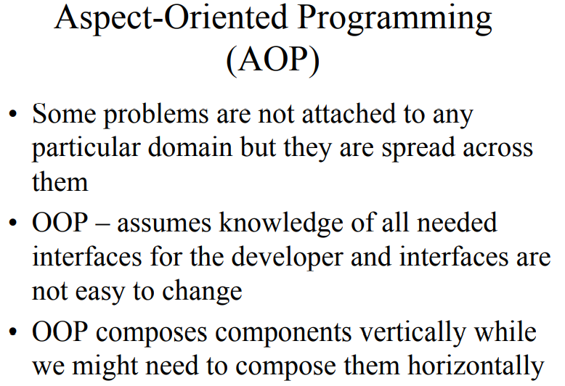

1. (2010) Briefly explain the main idea of Aspect-Oriented Programming. Give an example (答案在2010)

见6

1. (2008) Explain the approaches to class identification?

见5

1. (2007) Analysis model is composed of some other models. What are these models and when each of them is dominant?
   1. dynamic model: The model has many different types of events: Input, output, exceptions, errors, etc.
   2. object model: The system has objects with nontrivial state.
   3. Functional model: The model performs complicated transformations (e.g. computations consisting of many steps).
2. (2005) What are components of the Analysis model and which UML diagrams are used for their presentation?
   1. dynamic model: The model has many different types of events: Input, output, exceptions, errors, etc.
   2. object model: The system has objects with nontrivial state.
   3. Functional model: The model performs complicated transformations (e.g. computations consisting of many steps).

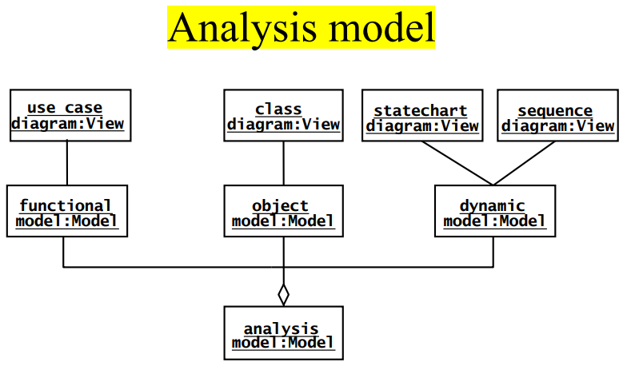

**System design**

1. (2020, 2017) What are advantages and disadvantages of open and closed layered architectures? Which of them is more suitable in which cases?
   1. Closed: Any layer can only invoke operations from the immediate layer below.
      1. High maintainability, flexibility, portable
   2. Open: Any layer can invoke operations from any layers below
      1. Runtime efficiency
2. (2020, 2019, 2018, 2015, 2013) In the course, we classified design goals into five categories: performance, dependability, cost, maintenance, and end user. Assign one or more categories to each of the following goals and briefly explain your answer:
   1. Users must be given a feedback within 1 second after they issue any command. performance, (end-user)
   2. The TicketDistributor must be able to issue train tickets, even in the event of a network failure. dependability, (end-user)
   3. The housing of the TicketDistributor must allow for new buttons to be installed in the event the number of different fares increases. maintenance
   4. The AutomatedTellerMachine must withstand dictionary attacks (i.e., users attempting to discover a identification number by systematic trial). dependability
   5. The user interface of the system should prevent users from issuing commands in the wrong order. end-user, (dependability)
3. (2018, 2015, 2013) What are benefits of layered architecture? What are main problems with this architecture?
   1. Layered systems are hierarchical. They are desirable because hierarchy reduces complexity (by low coupling). enable easier change of implementation
   2. Closed architectures are more portable.
   3. Open architectures are more efficient
   4. Layered systems often have a chicken-and egg problem – Example: Debugger
4. (2018, 2015, 2013, 2010) Older compilers were designed according to a pipe and filter architecture, in which each stage would transform its input into an intermediate representation passed to the next stage. Modern development environments, including compilers integrated into interactive development environments with syntactical text editors and source-level debuggers, use repository architecture. Identify the design goals that may have triggered the shift from pipe and filter to repository architecture.

More convenient to use, higher flexibility, loose coupling,

1. (2017) What are criteria for choosing file system or database as a data management solution?

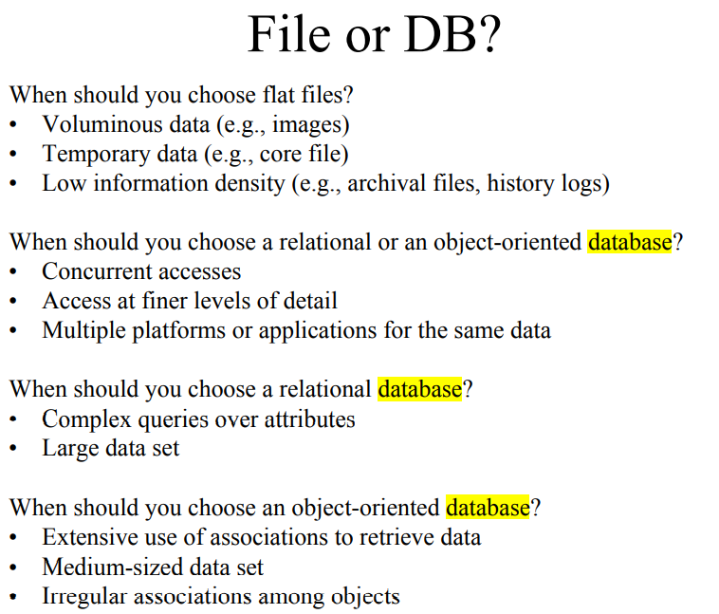

1. (2014, 2012) Explain the Pipe and Filter architectural style. For which systems it is suitable and for which systems it is not suitable?

subsystems process data received from a set of inputs and send results to other subsystems via a set of outputs. The subsystems are called “filters,” and the associations between the subsystems are called “pipes.”

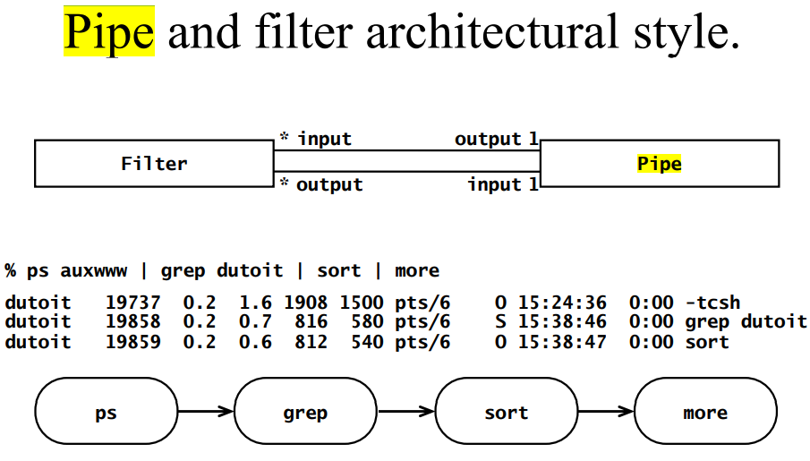

Pipe and filter styles are suited for systems that apply transformations to streams of data without intervention by users. They are not suited for systems that require more complex interactions between components, such as an information management system or an interactive system.

1. (2014, 2012) Explain the following terms: coupling, cohesion, partitioning and layering.

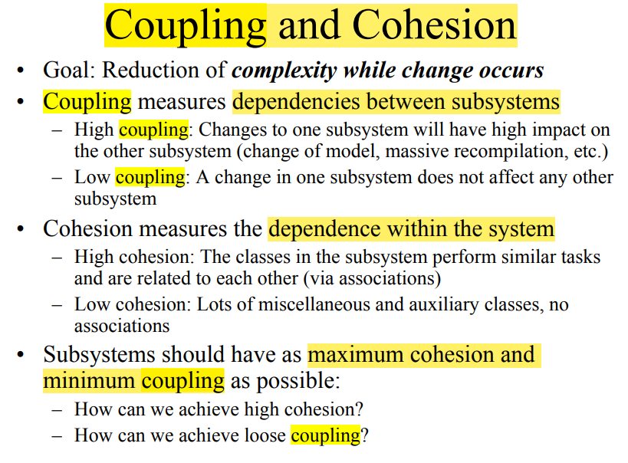

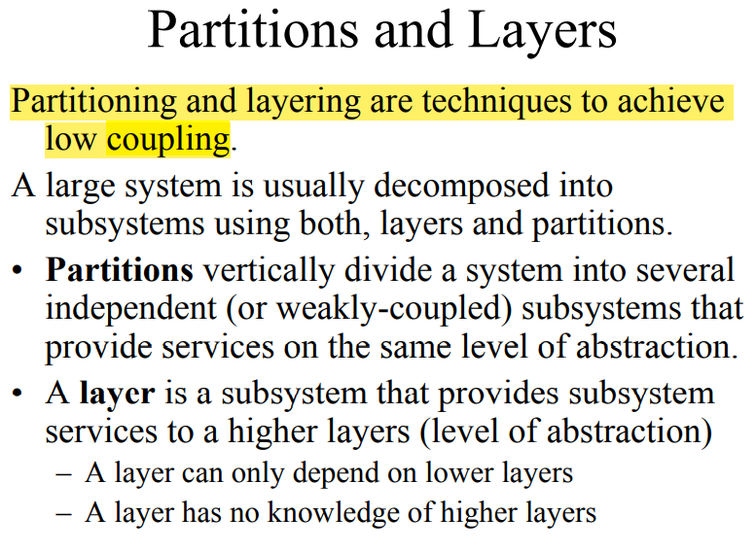

1. (2012) Which results from a Requirements Analysis are utilized in which particular System Design activities?

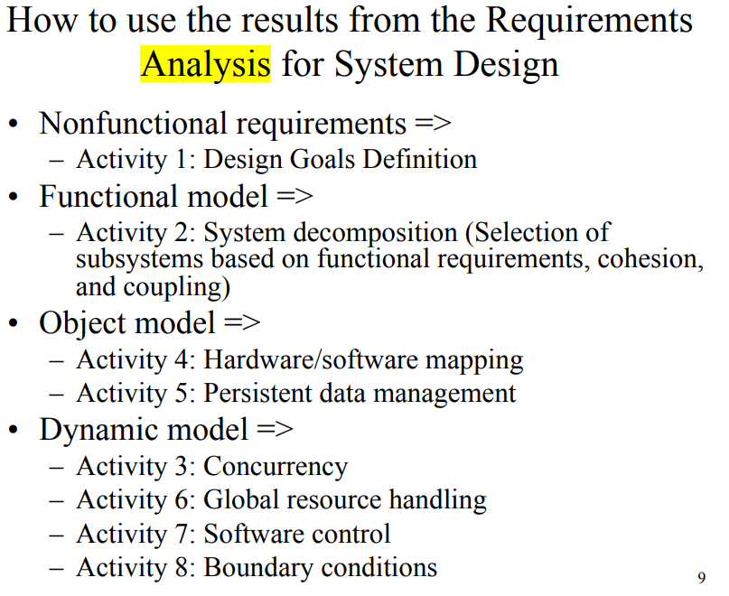

1. (2010) How boundary conditions are modeled during system design activity? Why they can’t be modeled during requirements activity?

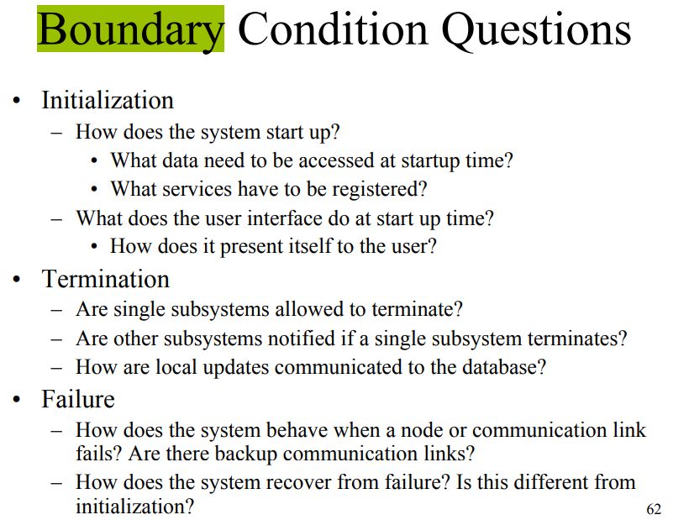

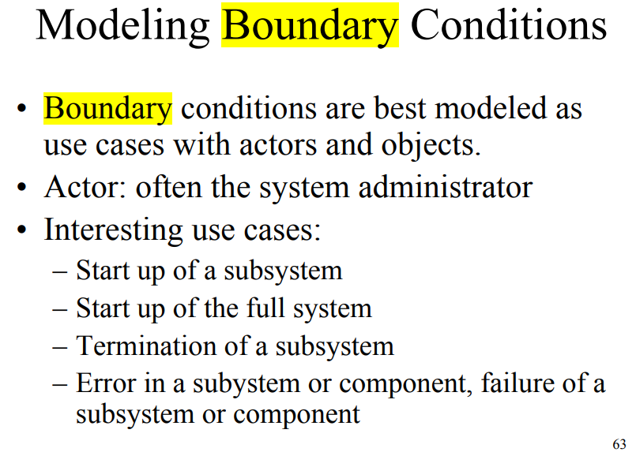

The boundary needs to be determined after system design.

1. (2008) Explain how the results from the Requirements Analysis can be used in different System Design activities.

见8

1. (2008) Explain Repository architectural style.

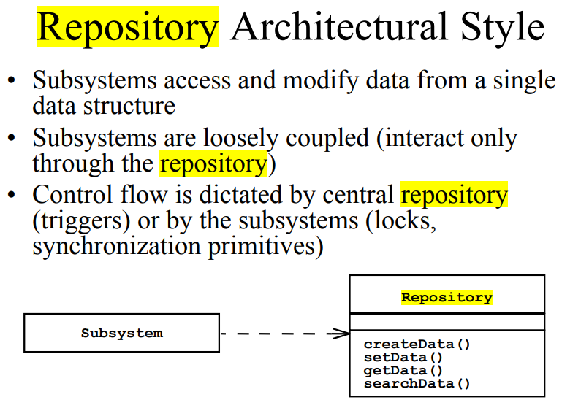

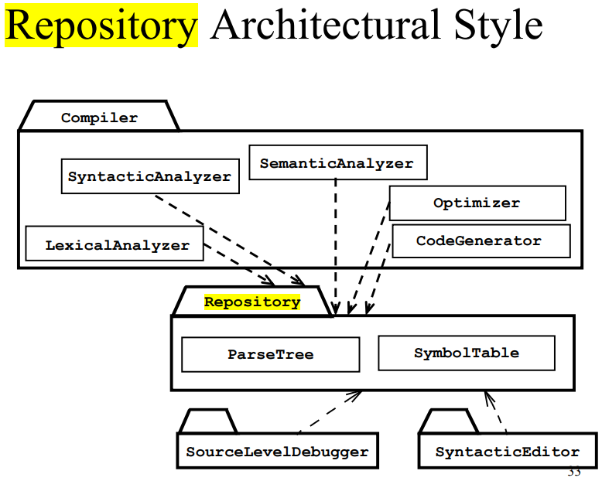

1. (2006) Why are use cases that describe boundary conditions described during system design (as opposed to during requirements elicitation or analysis)?

见9

1. (2005) Explain notions of coupling and cohesion. What are goals of system decomposition in terms of coupling and cohesion?



1. (2005) In many architectures, such as the three- and four-tier architectures, the storage of persistent objects is handled by a dedicated layer. In your opinion, which design goals have lead to this decision?

**Object design**

1. (2020, 2014) What are pros and cons for inheritance and delegation?

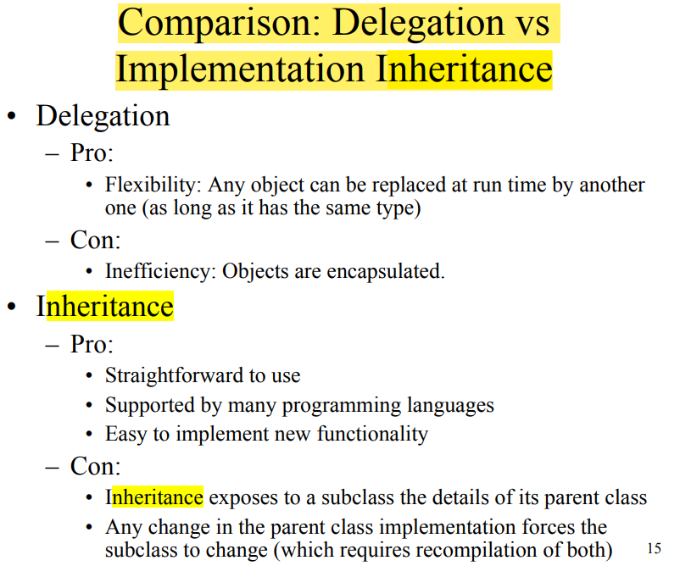

1. (2020, 2017) What is Observer pattern? Where it is applicable? Give an example.

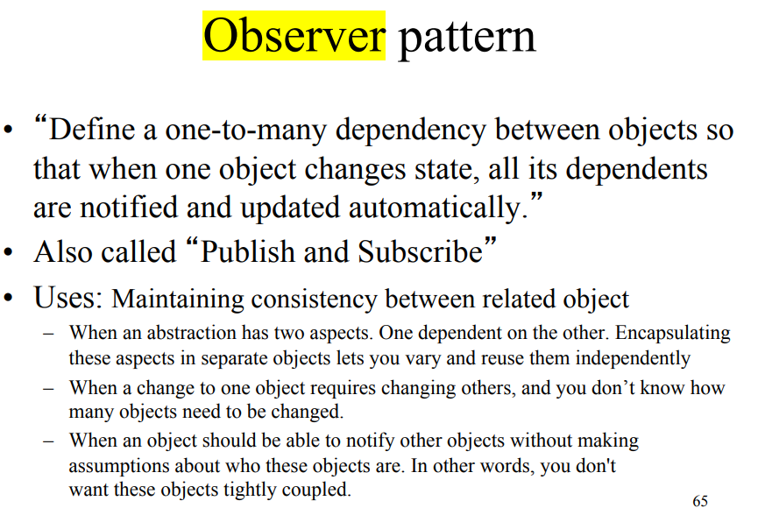

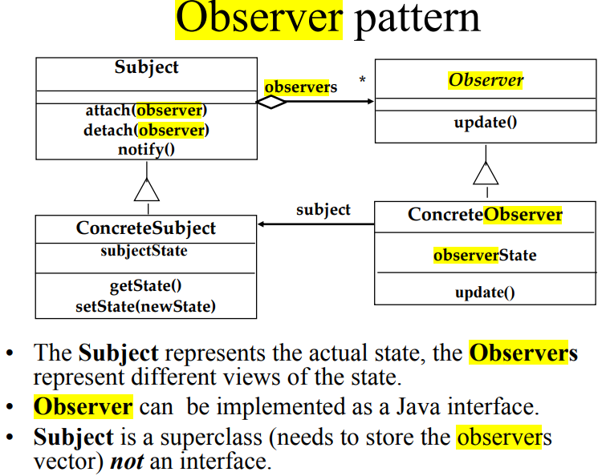

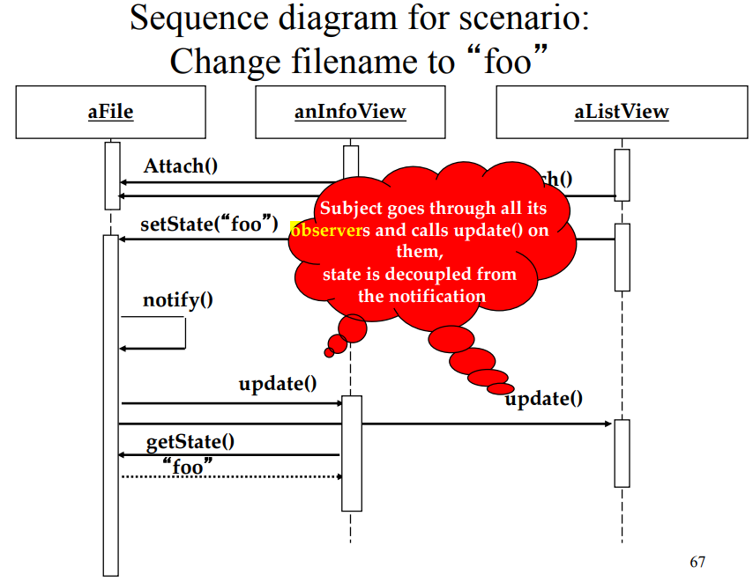

1. (2020) Consider the following design goals. For each of them, indicate the candidate design pattern(s) you would consider to satisfy each goal and briefly explain your answer:
   1. Given a legacy banking application, encapsulate the existing business logic component. adapter
   2. Given a chess program, enable future developers to substitute the planning algorithm that decides on the next move with a better one. bridge
   3. Given a chess program, enable a monitoring component to switch planning algorithms at runtime, based on the opposing player’s style and response time. Strategy
   4. Given a simulation of a mouse solving a maze, enable the path evaluation component to evaluate different paths independently of the types of moves considered by the mouse. command
2. (2020, 2017, 2007) Indicate which occurrences of the following inheritance relationships are specification inheritance and which are implementation inheritance (briefly explain your answer):
   1. A Rectangle class inherits from a Polygon class. specification
   2. A Set class inherits from a BinaryTree class. implementation
   3. A Set class inherits from a Bag class (a Bag is defined as an unordered collection). specification
   4. A Player class inherits from a User class. specification
   5. A Window class inherits from a Polygon class. implementation
3. (2019, 2018, 2015, 2013) Consider an application that must select dynamically an encryption algorithm based on security requirements and computing time constraints. Which design pattern would you select? Draw a UML class diagram depicting the classes in the pattern and justify your choice.
4. (2018, 2015, 2013) Explain how delegation, implementation and specification inheritance are shown in UML class diagrams. Explain difference between implementation inheritance, specification inheritance and delegation.

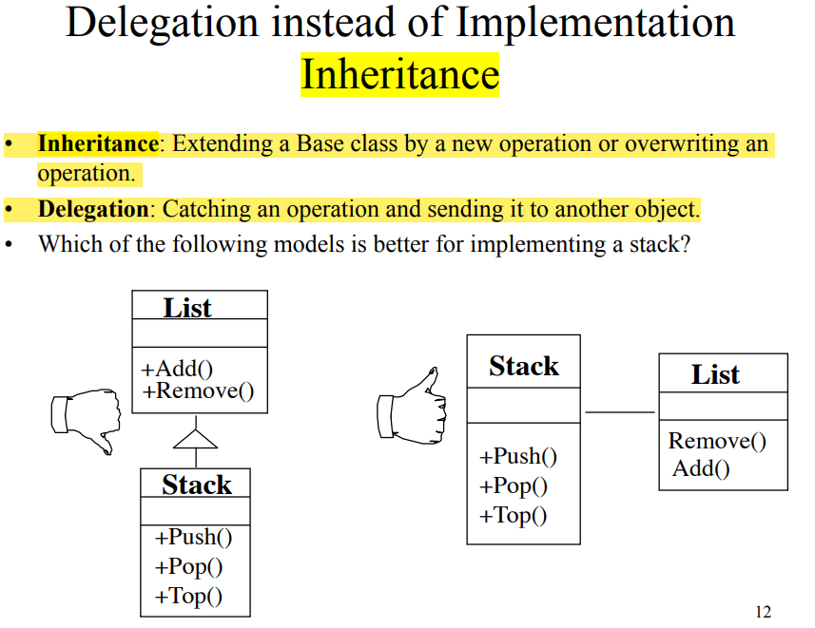

1. (2014) Explain Command pattern. When is it applicable?

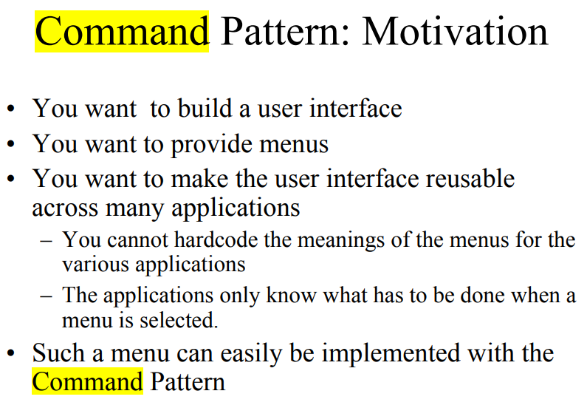 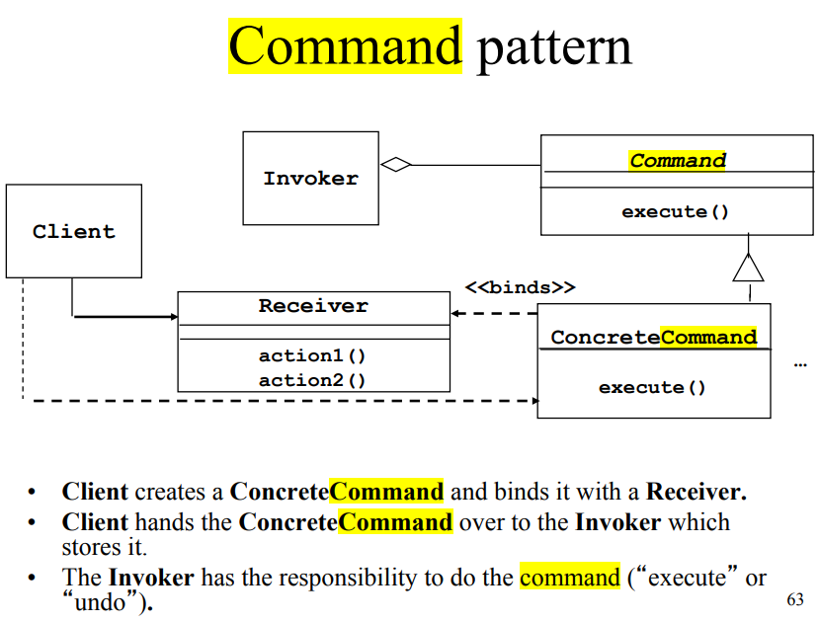

1. (2012, 2009) If you are given a choice of using implementation inheritance, delegation or specification inheritance for reuse how do you put priorities among them for usage? Briefly explain.

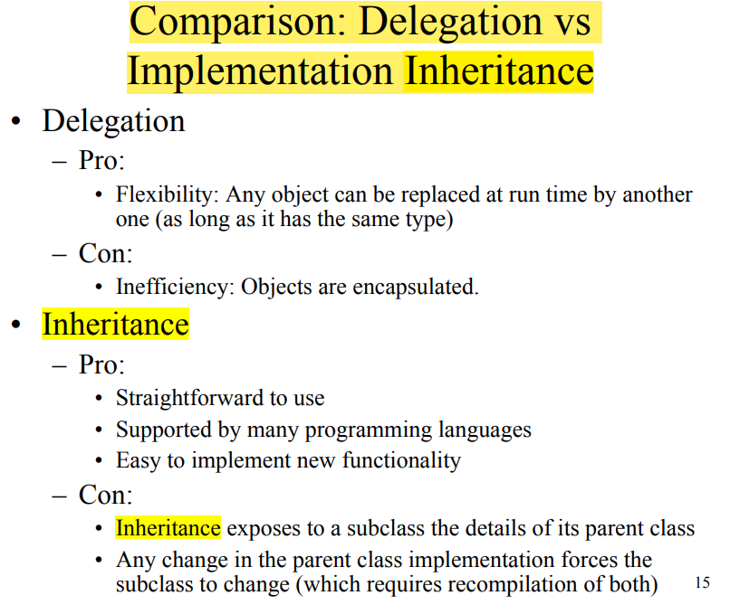

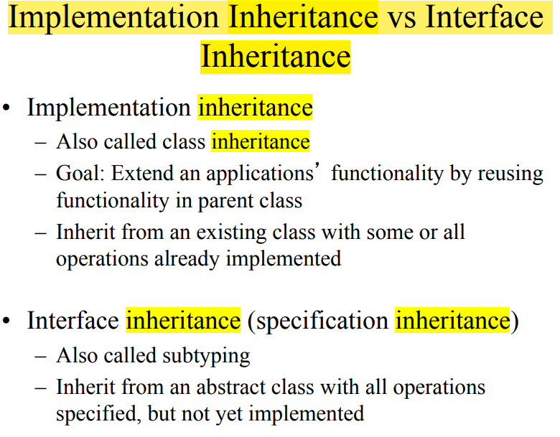

1. (2012) Assume that you are developing a system that stores its data on a Unix file system. You anticipate that you will port future versions of the system to other operating systems that provide different file systems. Which design pattern would you use in order to anticipate this change? Explain your answer.
2. (2010) What is the Liskov Substitution principle? Which type of inheritance it defines? What are benefits of design following this principle?

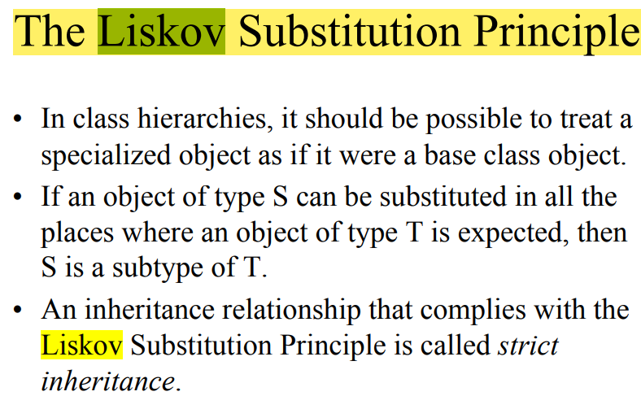

1. (2010) What are similarities and differences between Adapter and Bridge patterns?

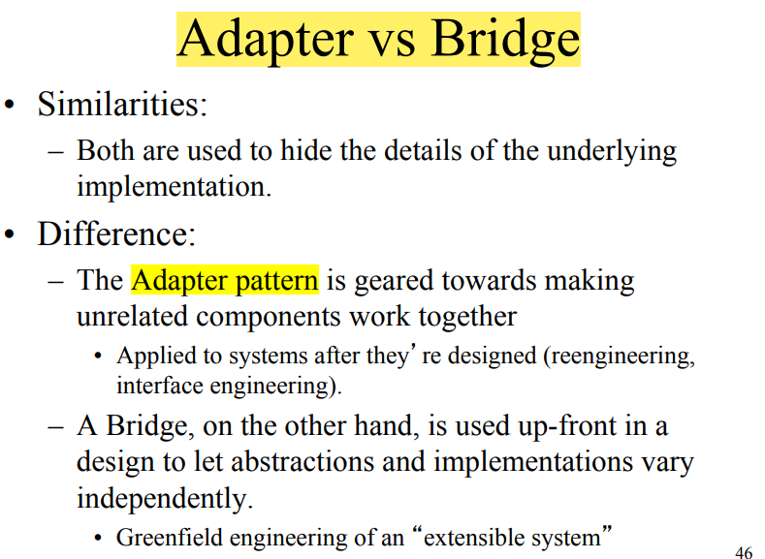

1. (2009) Briefly explain in which cases it is reasonable to use each of the following design patterns: Adapter, Bridge, Proxy and Strategy.

Text: must interface with an existing object – Adapter Pattern

Text: must deal with the interface to several systems, some of them to be developed in the future , an early prototype must be demonstrated – Bridge Pattern

Text: must be location transparent – Proxy Pattern

Text: must provide a policy independent from the mechanism – Strategy Pattern

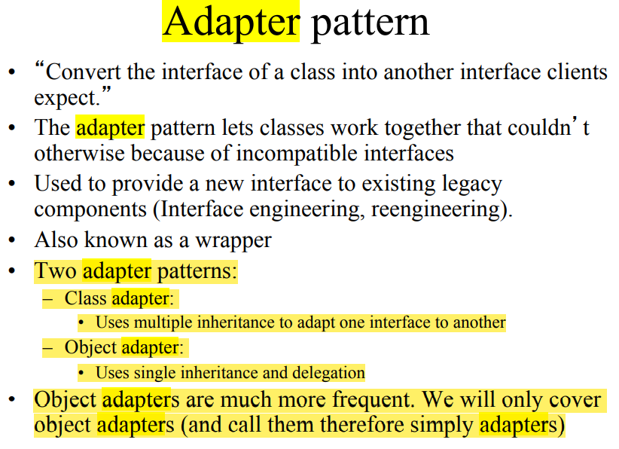

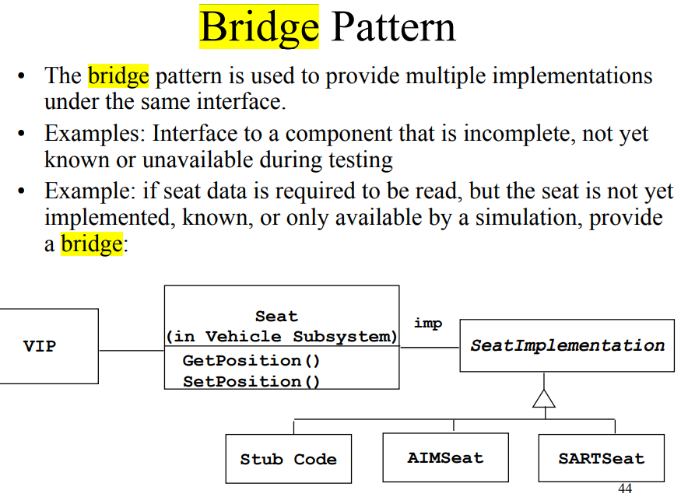

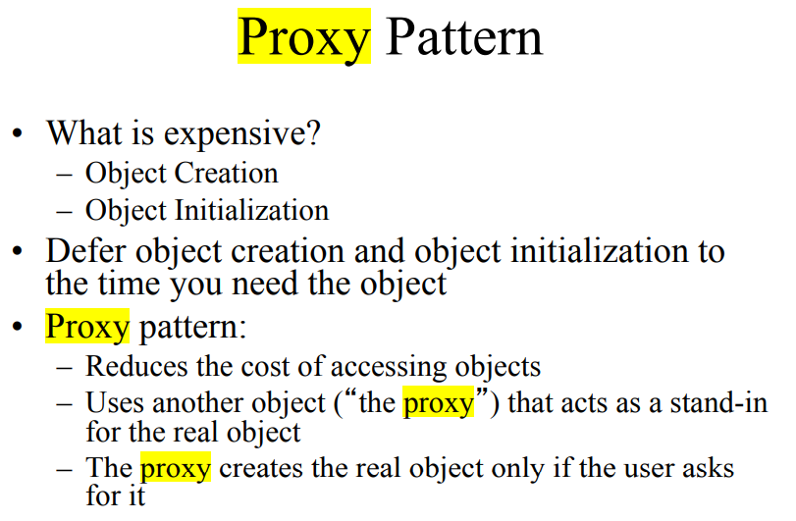

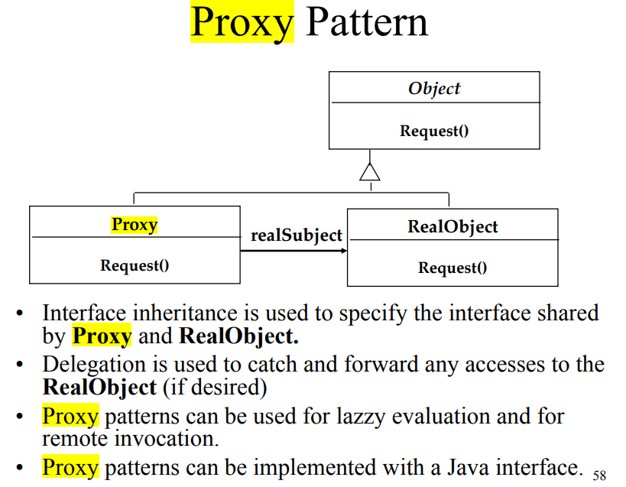

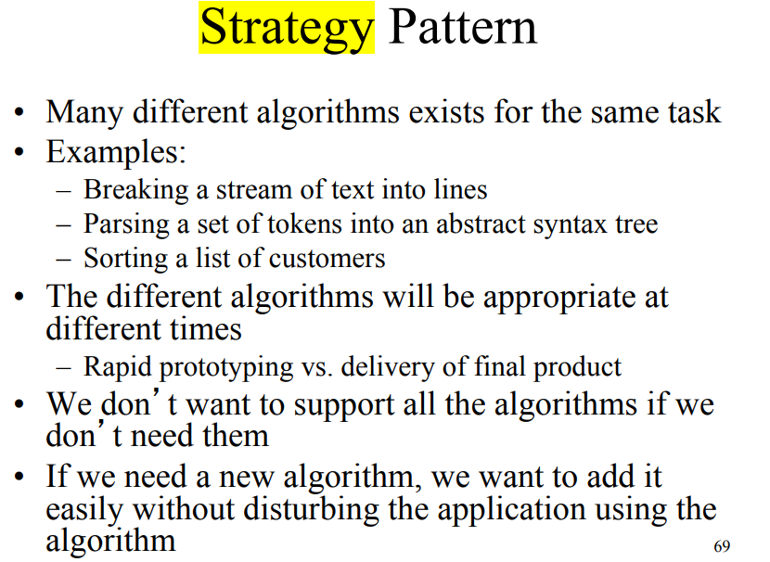

1. (2006) What is the Abstract Factory pattern? In which cases it is applicable? Give an example.

this pattern shields a system from the concrete classes provided by a specific platform, such as a windowing style or an operating system. provides an interface for creating families of related or dependent objects without specifying their concrete classes. Encapsulating Platforms with the Abstract Factory Pattern

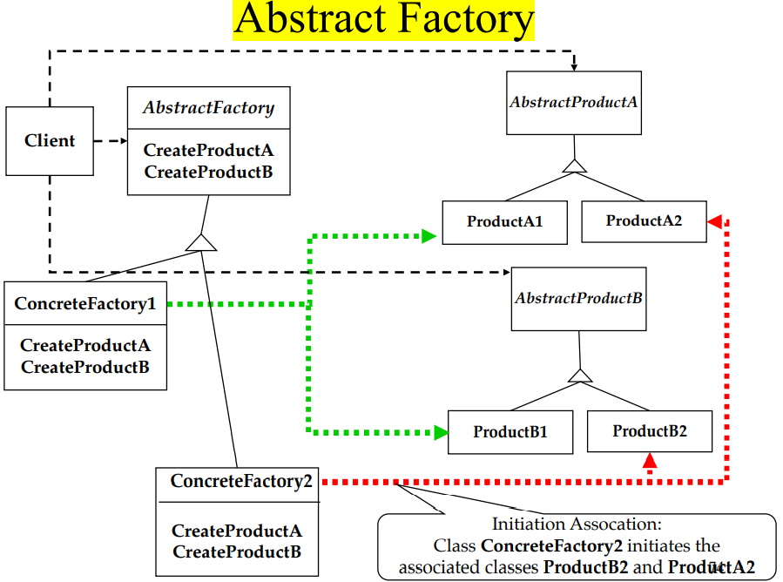

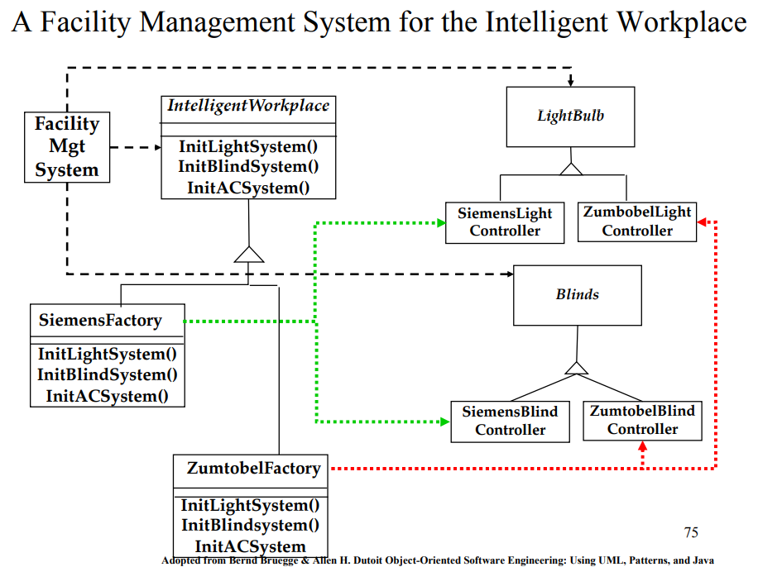

1. (2005) Explain Adapter pattern. What is difference between class Adapter pattern and object Adapter pattern?

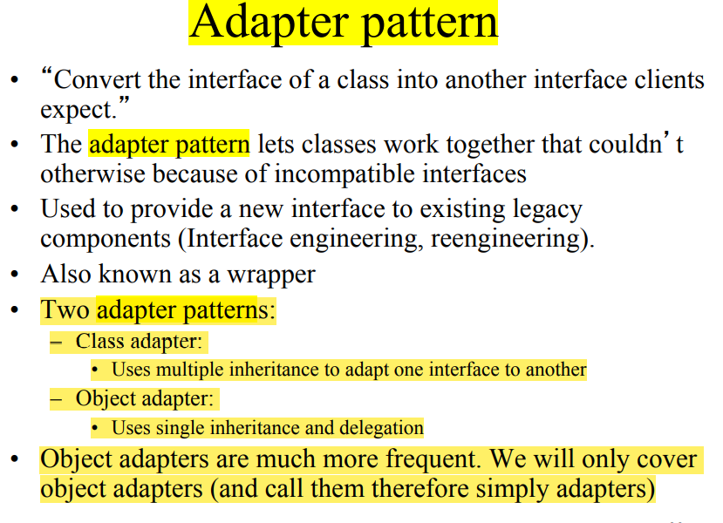

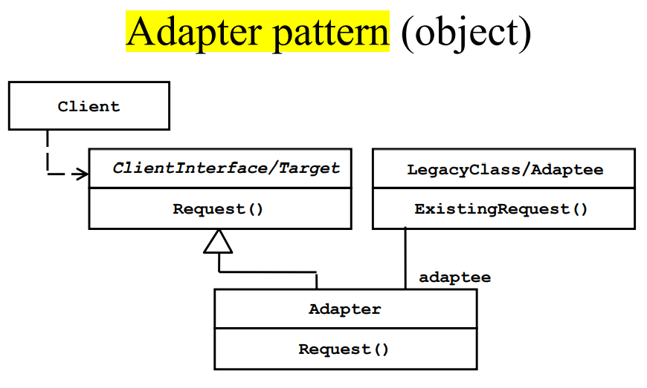

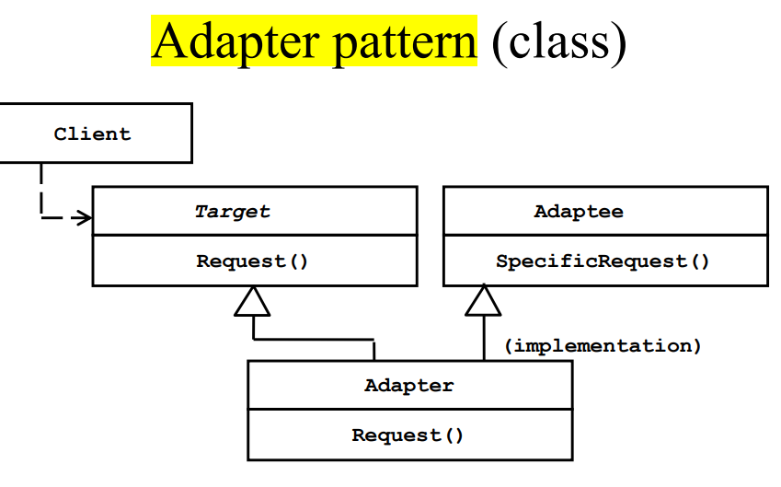

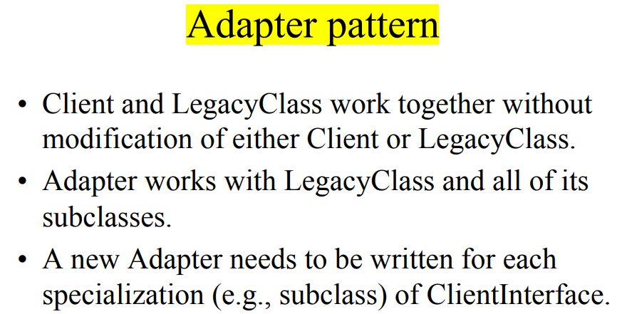

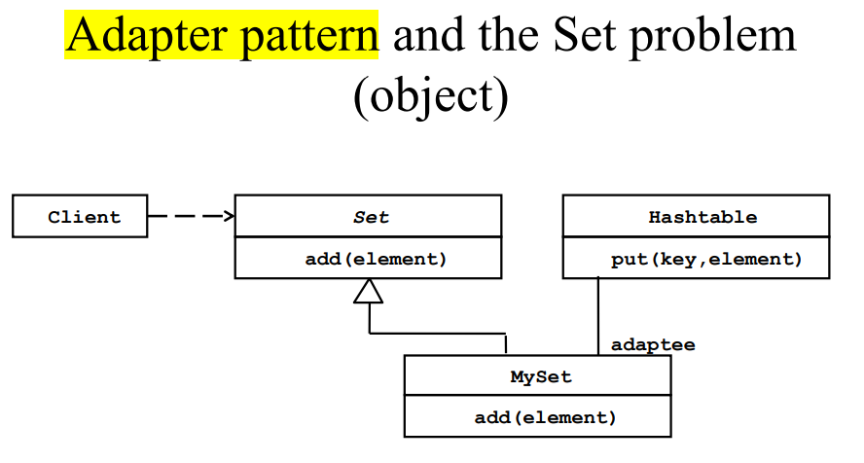

**Interface design**

1. (2020, 2017) Explain meaning of invariant, pre-condition and post-condition. Give their examples.
   1. Invariant: A predicate that is always true for all instances of a class.
   2. pre-condition: A predicate that must be true before an operation is invoked.
   3. Post-condition: A predicate that must be true after an operation is invoked.
2. (2019, 2014) Consider a sorted binary tree data structure for storing integers. Write invariants in OCL denoting that
   1. All nodes in the left subtree of any node contain integers that are less than or equal to the current node, or the subtree is empty.
   2. All nodes in the right subtree of any node contain integers that are greater than the current tree, or the subtree is empty.
3. (2018) Consider a simple intersection with two crossing roads and four traffic lights. Assume a simple algorithm for switching lights, so that the traffic on one road can proceed while the traffic on the other road is stopped. Model each traffic light as an instance of a TrafficLight class with a state attribute that can be either red, yellow, or green. Write invariants in OCL on the state attribute of the TrafficLight class that guarantee that the traffic cannot proceed on both roads simultaneously. Add associations to the model to navigate the system, if necessary.
4. (2017, 2012, 2009) Assume that you have the following 3 classes: parallelogram, rhombus and square. Assume that rhombus inherits from parallelogram and square inherits from rhombus. Write invariants in OCL for each of these classes taking into account the inheritance of contracts.
5. (2015, 2013, 2010) Consider a class diagram in the Figure 3

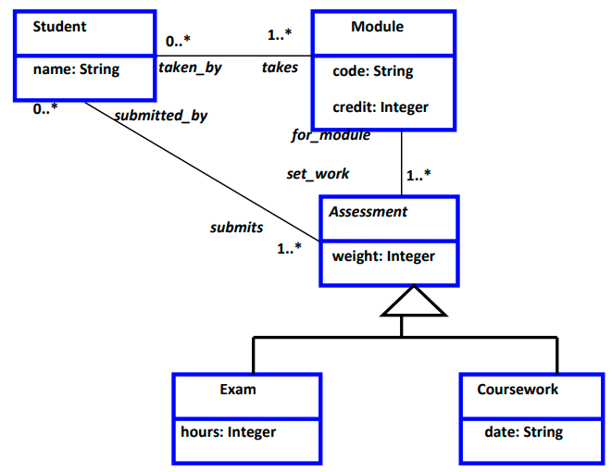

Your task is to define in OCL the following constraints:

* 1. Modules can be taken if they have more than seven students registered
  2. The assessments for a module must total 100%
  3. Students must register for 120 credits each year

1. (2014) Which types of navigations through a class diagram exists? Give examples of constraints using each type of navigation

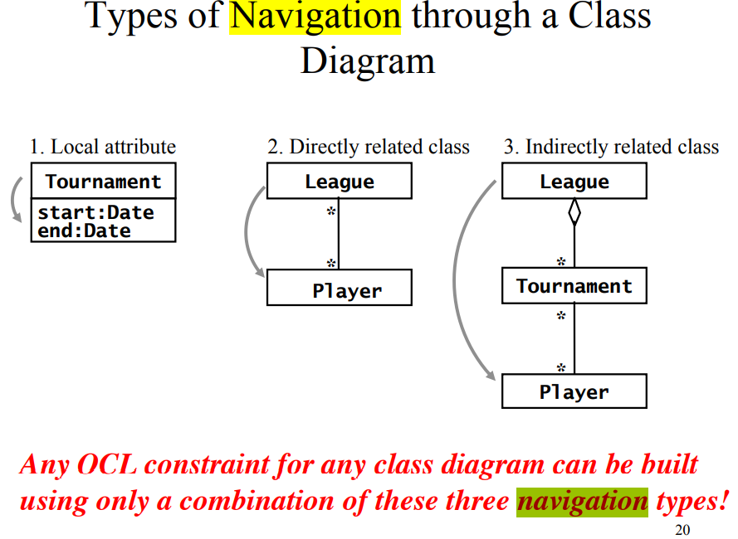

1. (2007) How does contract inheritance work? Explain for each type of constrains.

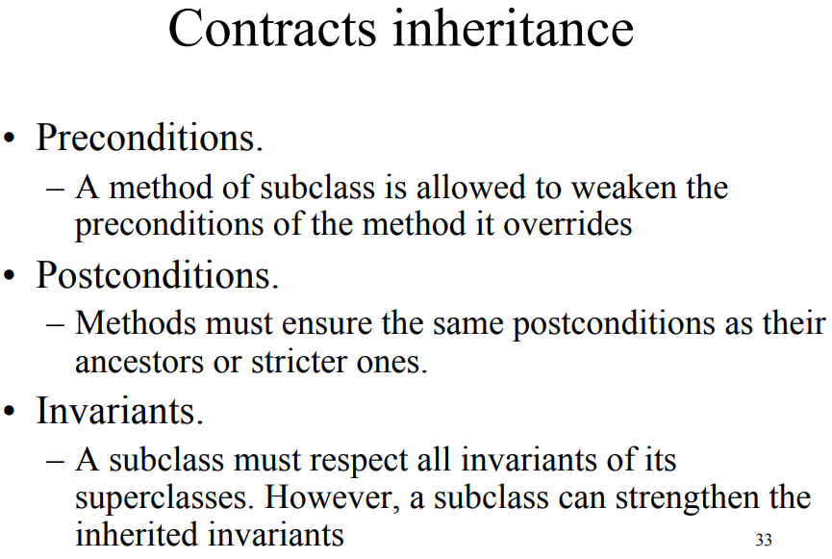

1. (2007) Assume that we have a Rectangle class that inherits from a Parallelogram class. Write invariant(s) in OCL for the Rectangle class.
2. (2006) What are contracts and what do they include?

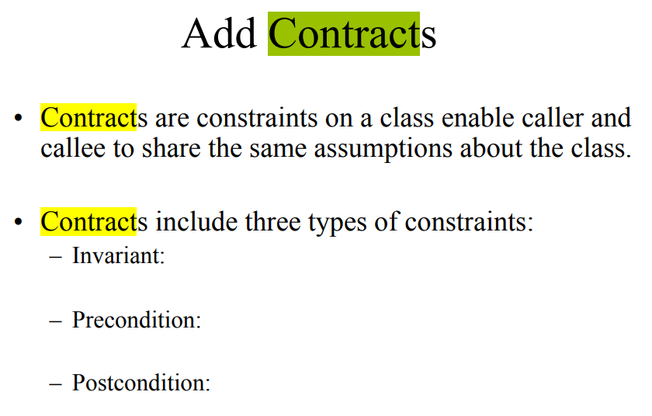

1. (2006) Explain meaning of sets, sequences and bags in OCL. For which type(s) of navigation each of them is used? Explain why.

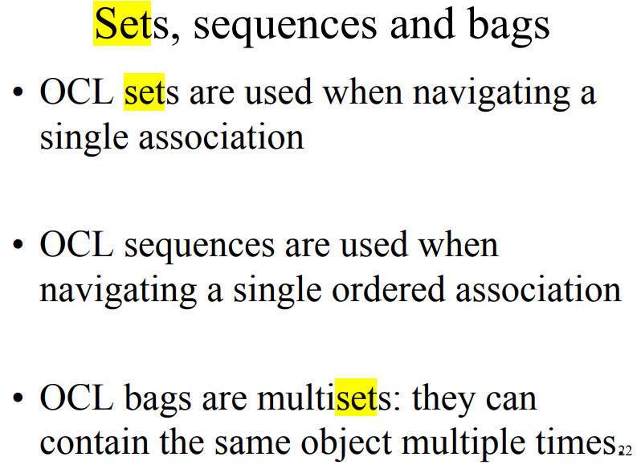

1. (2005) Which different roles play developers in Object design and how it is reflected in UML diagrams?
2. (2005) Consider the List interface in the java.util package for ordered collections of objects. Write preconditions and post conditions in OCL for the following operations:
   1. int size() returns the number of elements in the list.
   2. void add(Object e) adds an object at the end of the list.
   3. void remove(Object e) removes an object from the end of the list.
   4. boolean contains(Object e) returns true if the object is contained in the list.
   5. Object get(int idx) returns the object located at index idx, 0 being the index of the first object in the list.

**Move to code**

1. (2019, 2015, 2013, 2007) Explain the following mapping concepts: model transformation, forward engineering, reverse engineering and refactoring. Draw a figure showing their relations to model space and source code space.
   1. model transformation: A transformation that is applied to an object model and results in another object model. The purpose of object model transformation is to simplify or optimize the original model, bringing it closer to a system that complies with all requirements in the specification.
   2. forward engineering: The process of applying a transformation to a set of model elements, resulting in a set of corresponding source code statements, such as a class declaration, a Java expression, or a database schema. Contrast with reverse engineering.
   3. reverse engineering: The process of applying a transformation to a set of source code elements, resulting in a set of model elements. The purpose of reverse engineering is to recreate the model for an existing system, either because the model was lost, never created, or because it became out of sync with the source code. Contrast with forward engineering.
   4. refactoring: Transformation of the source code that improves its readability or modifiability without changing the behavior of the system. Refactoring aims at improving the design of a working system by focusing on a specific field or method of a class

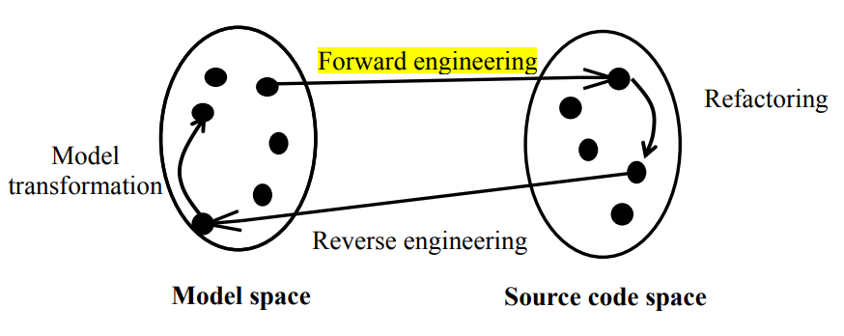

1. (2018, 2017, 2015, 2013, 2012, 2010) Explain realization of a unidirectional, one-to-one association in source code.

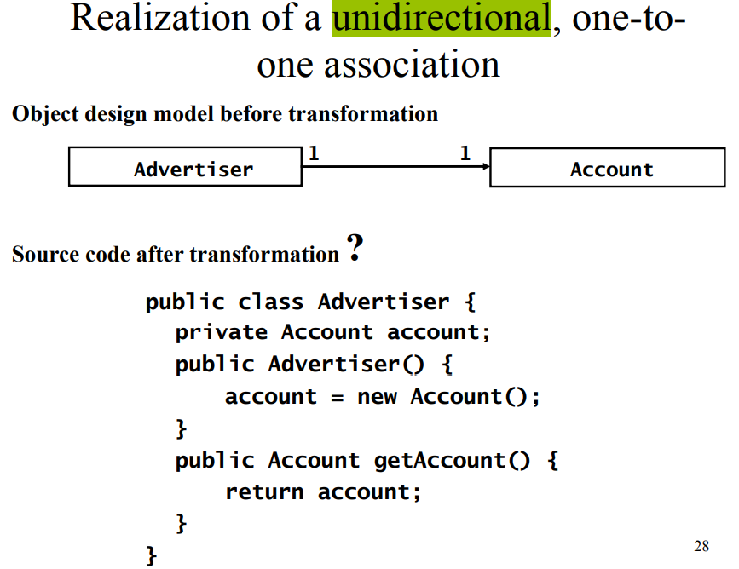

1. (2014) Explain two ways of mapping inheritance to relational database. When each of them is more preferable?

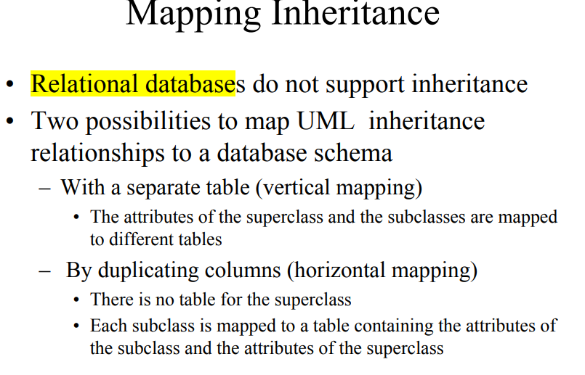

1. (2009) There are 2 different ways of mapping inheritance into the relational database tables: with a separate table and by duplicating columns. Explain these ways with examples and compare them in terms of modifiability and response time.

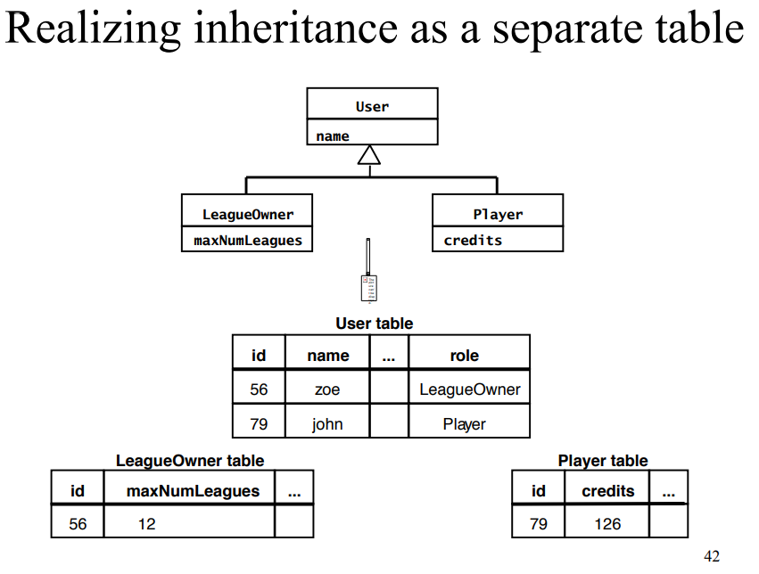

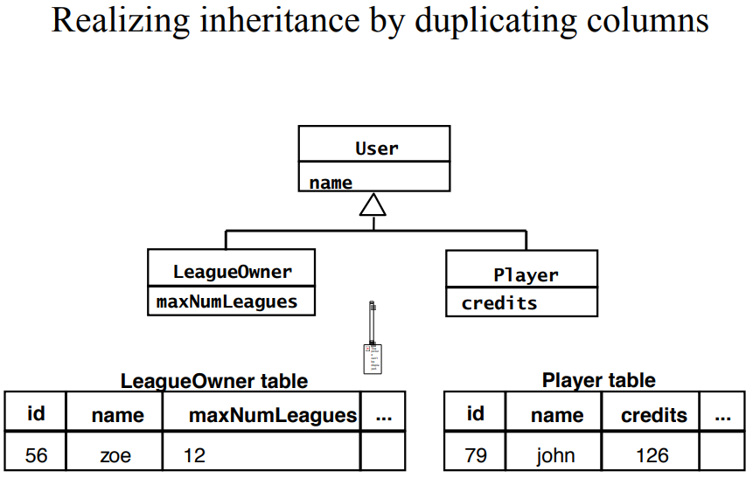

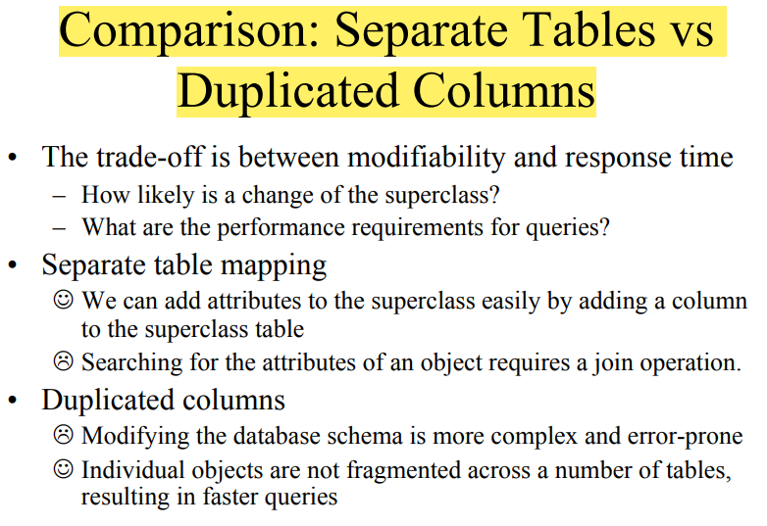

1. (2009) If we consider forward engineering then what is a transformation that we can apply to map class diagram into code?

Private, public, protected

1. (2007) Explain different ways of mapping inheritance into relational database schema. Give their pros and cons.

见4

1. (2006) Let us consider mapping of classes to relational tables. Explain how one-to-may associations are mapped in this case.

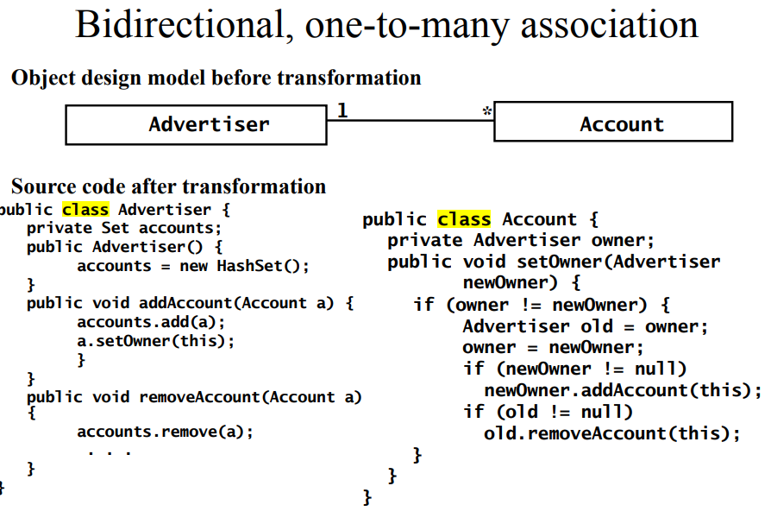

**Agile**

1. (2019, 2018, 2015, 2013) What are main ideas of the Manifesto of Agile Software Development?

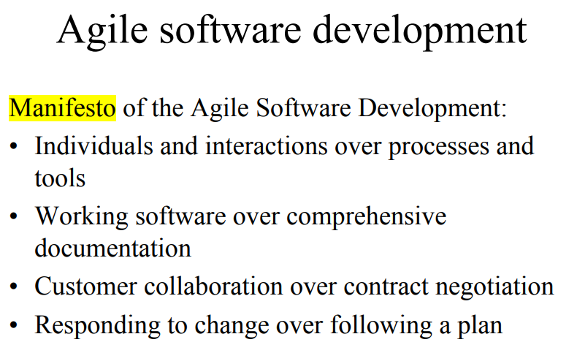

1. (2012, 2009) What is metaphor in Extreme programming? Give examples of at least 3 metaphors.

The system metaphor is a story that everyone—customers, programmers, and managers—can tell about how the system works

1. (2010) What is Spike in the Extreme programming and when it is used? Give an example

Quick throw-away explorations into the nature of a potential solution

1. (2008) What is test-driven (test-first) software development? Briefly explain.

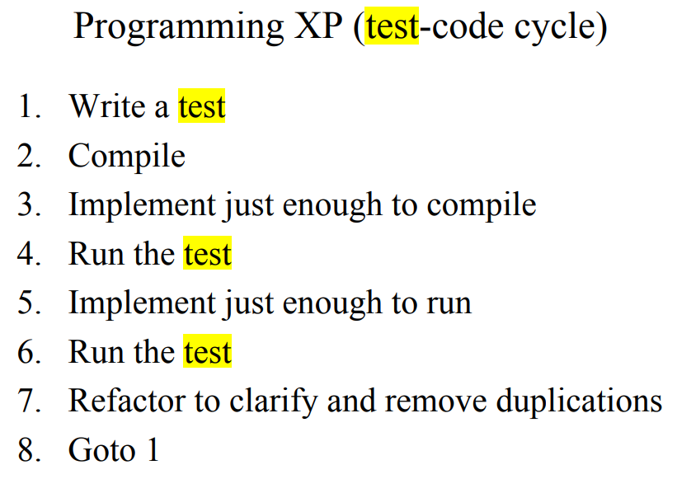

**Test**

1. (2020, 2017) What are pro and cons for black-box and white-box testing?
   1. Black-box testing (Test the input/output behavior)
   2. White-box testing (Test the internal logic of the subsystem or object)

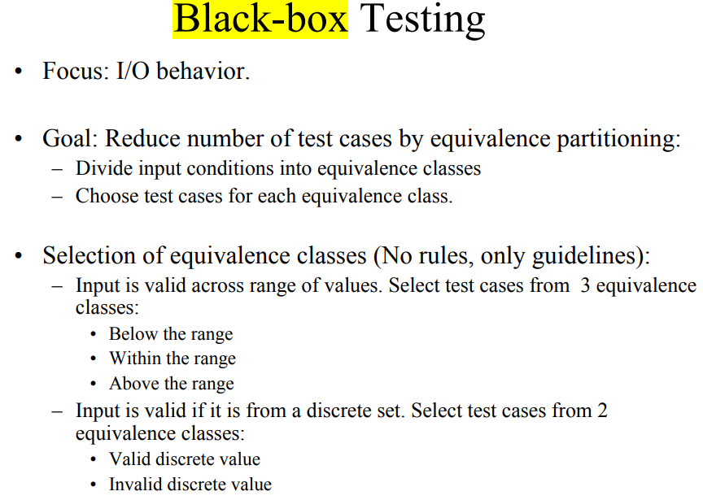

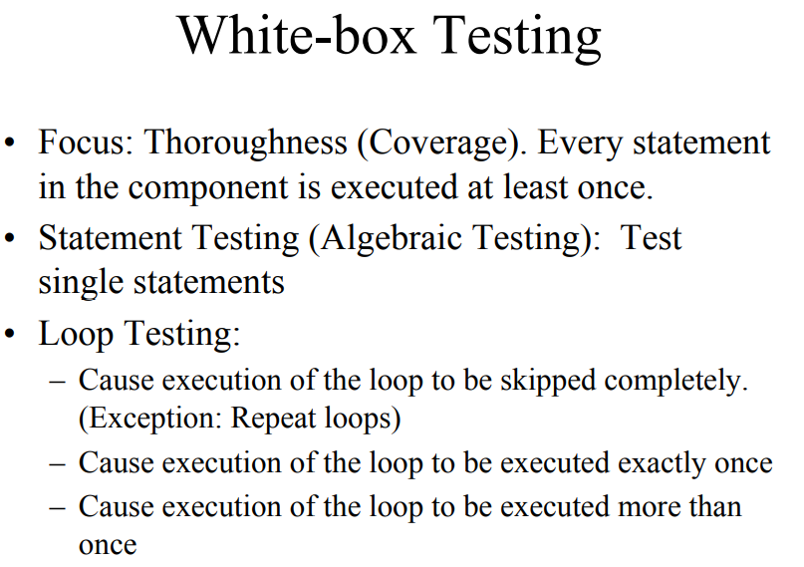

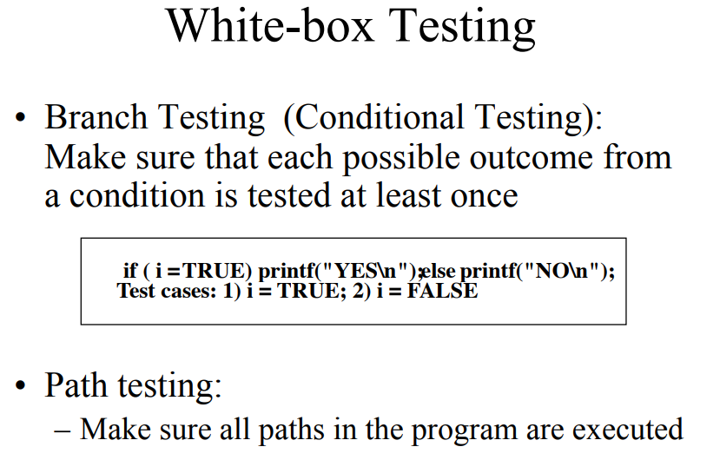

1. (2018, 2015, 2013) Explain the following testing concepts: Reliability, Fault, Erroneous state, Failure.

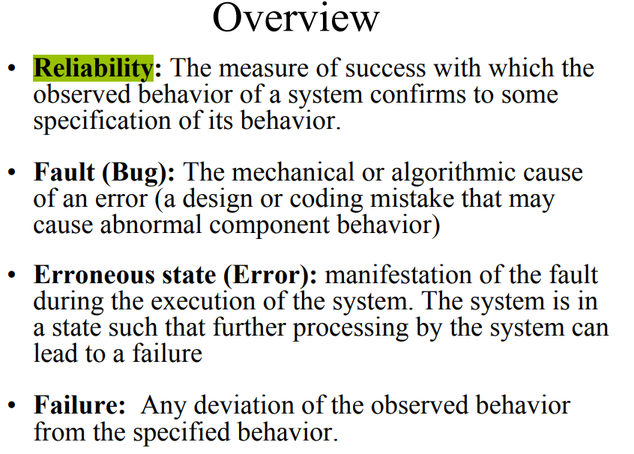

1. (2017) Compare advantages and disadvantages of bottom-up and top-down integration testing strategies.

The advantage of bottom-up testing is that interface faults can be more easily found: when the developers substitute a test driver for a higher-level component, they have a clear model of how the lower-level component works and of the assumptions embedded in its interface. If the higher-level component violates assumptions made in the lower-level component, developers are more likely to find them quickly. The disadvantage of bottom-up testing is that it tests the most important subsystems, namely the components of the user interface, last. Faults found in the top layer may often lead to changes in the subsystem decomposition or in the subsystem interfaces of lower layers, invalidating previous tests. The advantage of top-down testing is that it starts with user interface components. The same set of tests, derived from the requirements, can be used in testing the increasingly more complex set of subsystems. The disadvantage of top-down testing is that the development of test stubs is time-consuming and prone to error. A large number of stubs is usually required for testing nontrivial systems, especially when the lowest level of the system decomposition implements many methods.

1. (2014) If a program has 2 integer inputs and each can be 32-bit integer, how many possible inputs does this program have?
2. (2014) Why do we use equivalence classes in testing?

Reduce number of test cases

1. (2012) What is a goal of partitioning of possible inputs into equivalence classes in black-box testing? What are guidelines for selection of equivalence classes?

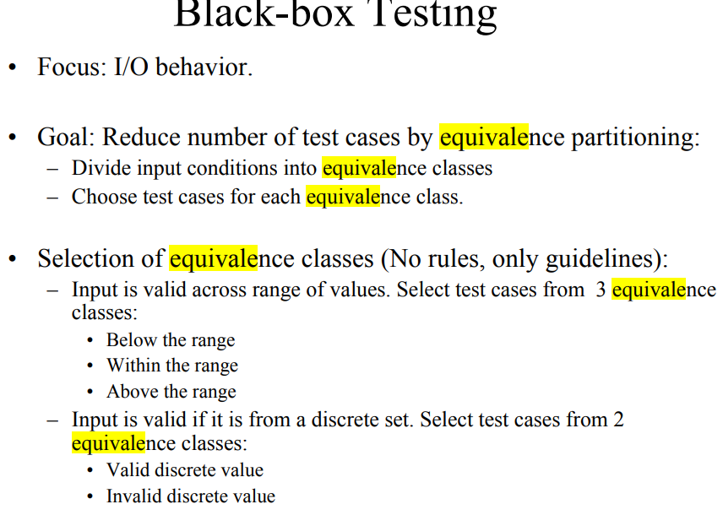

1. (2010) Explain modified sandwich testing strategy. What are advantage(s) and disadvantage(s) of this strategy?

An integration testing strategy that combines top-down and bottom-up testing. The modified sandwich testing strategy tests the three layers individually before combining them in incremental tests with one another. The individual layer tests consists of a group of three tests:

a top layer test with stubs for the target layer

a target layer test with drivers and stubs replacing the top and bottom layers

a bottom layer test with a driver for the target layer.

The combined layer tests consist of two tests:

The top layer accesses the target layer. This test can reuse the target layer tests from the individual layer tests, replacing the drivers with components from the top layer.

The bottom layer is accessed by the target layer. This test can reuse the target layer tests from the individual layer tests, replacing the stub with components from the bottom layer

The advantage of modified sandwich testing is that many testing activities can be performed in parallel, as indicated by the activity diagrams of Figures 11-21 and 11-22. The disadvantage of modified sandwich testing is the need for additional test stubs and drivers. Overall, modified sandwich testing leads to a significantly shorter overall testing time than top-down or bottom-up testing.

1. (2010) Give a formula for calculation of the minimal number of tests required in the path testing. This calculation depends on the number of nodes and edges in the equivalent flow graph of the program.
2. (2008) Briefly explain which different types of tests are performed during testing. Who performs each of them?

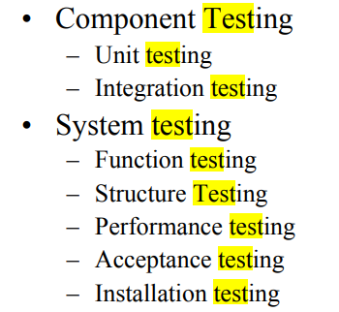

1. (2006) Let us consider a path testing. What is a minimum number of tests necessary in order to exercise all possible paths through the code at least once?
2. (2006) What is state-based testing and what are difficulties with it?
3. (2005) What is path testing? Is it white-box or black-box technique? Does it allow to identify all faults? Explain your answer.

